**BUILDING A FACE DETECTION APP ON AWS**

By

**HEMANTH RAMARAO BATCHU**

**(Reg. No.: 19MVD0102)**

**M.Tech VLSI Design**

**VIT, VELLORE**

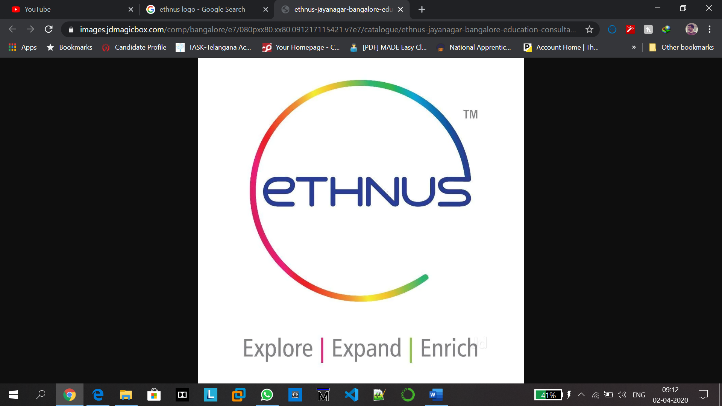

**SCHOOL OF ELECTRONICS ENGINEERING**

**VIT UNIVERSITY**

**VELLORE-632014, TAMIL NADU, INDIA**

**MARCH 2020**

PART 1:

# **1. AWS LOGIN SCREEN WITH USERNAME:**

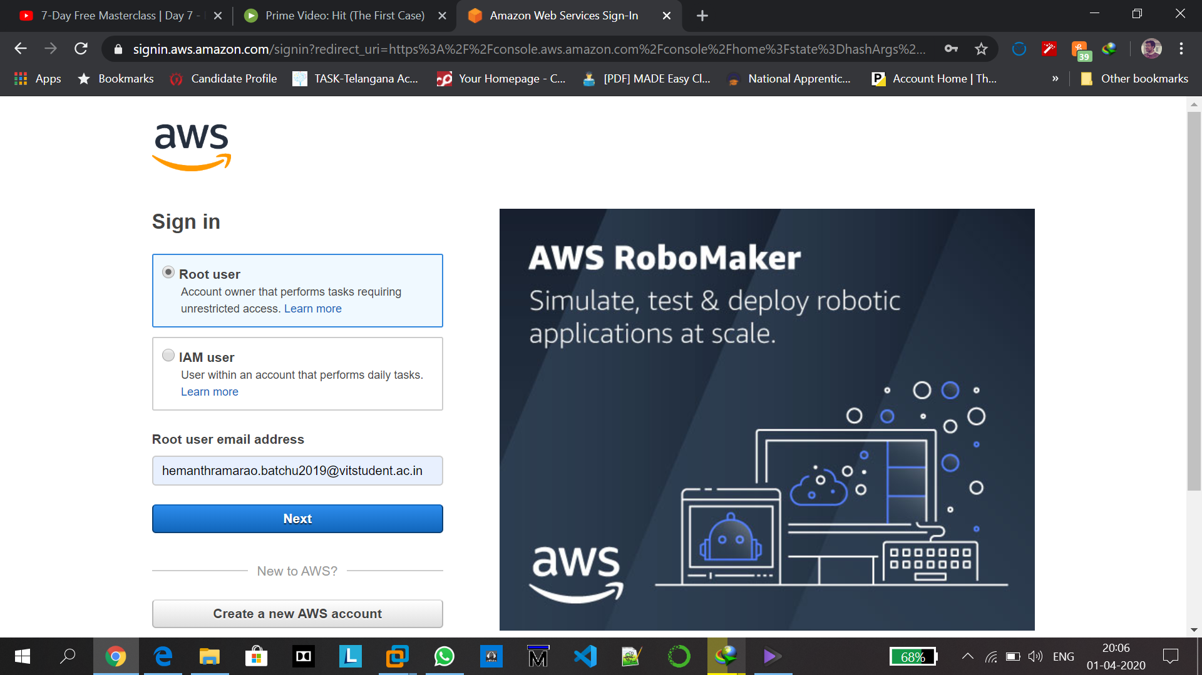

# **2. EC2 Dashboard:**

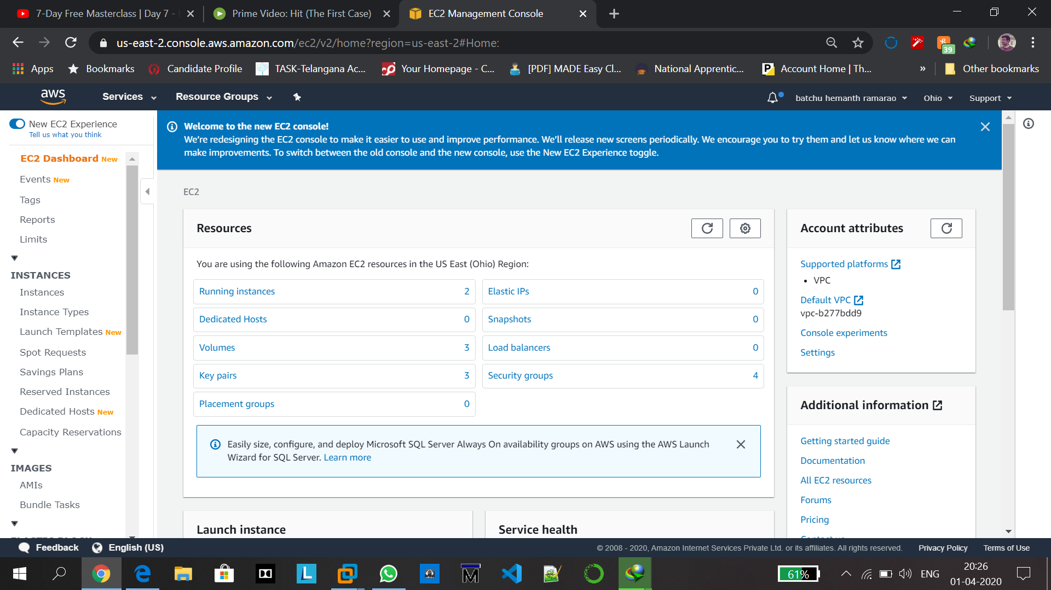

# **3. S3 Dashboard:**

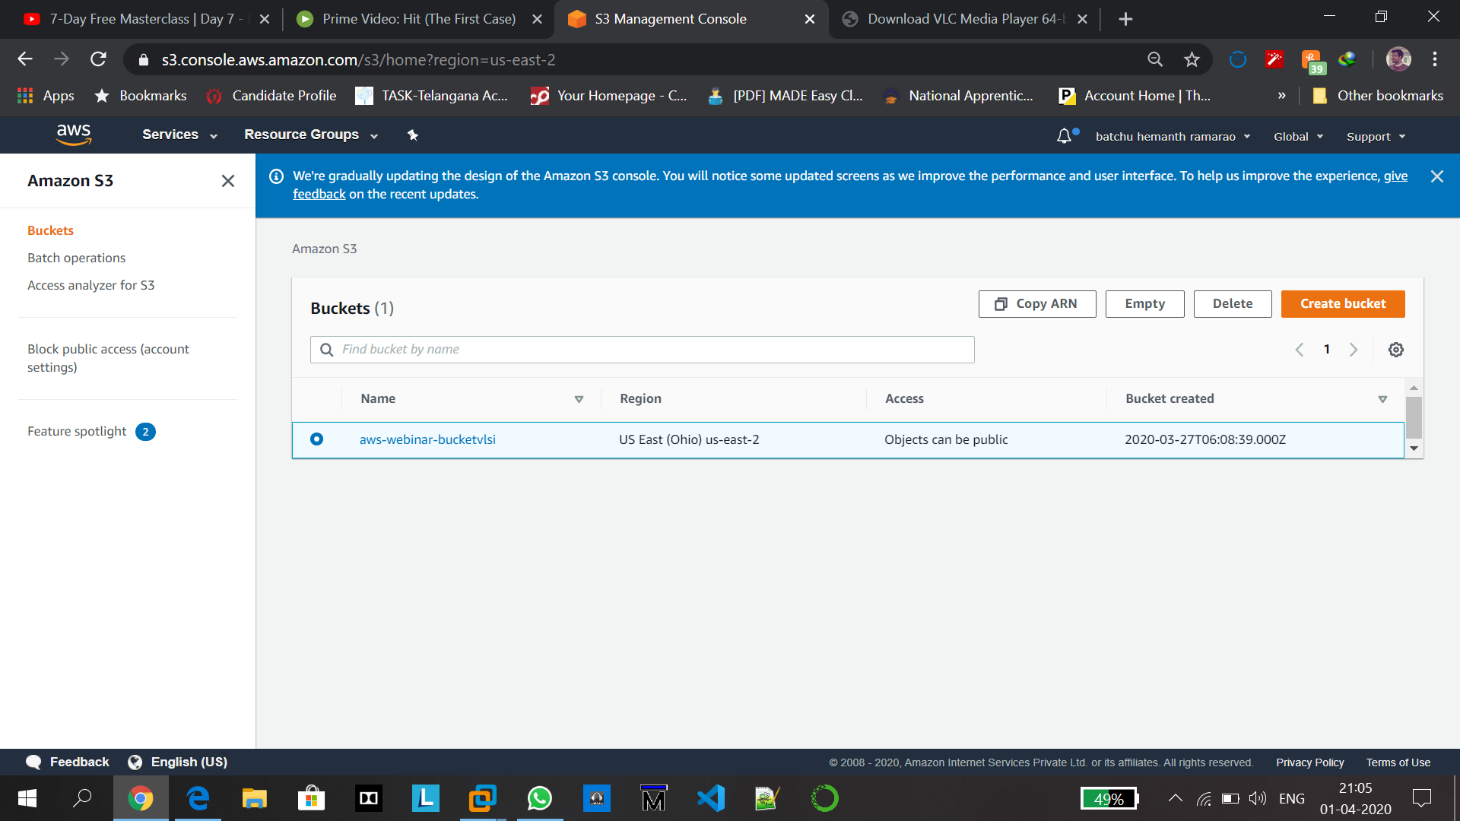

# **4. Rekognition Dashboard:**

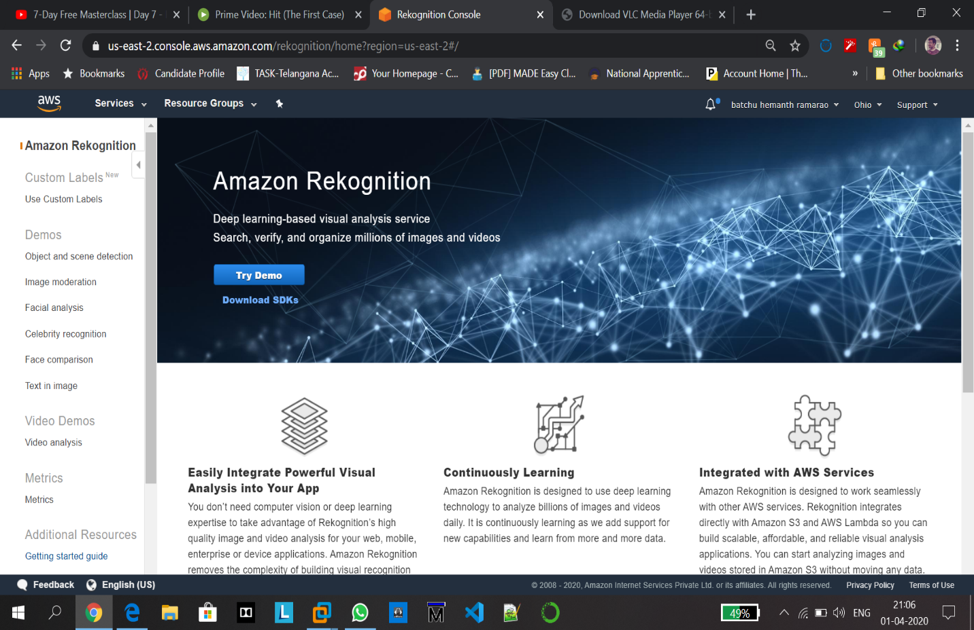

# **Part 2: EC2**

# **5. Choosing an AMI:**

First of all click on create instance and this screen appears

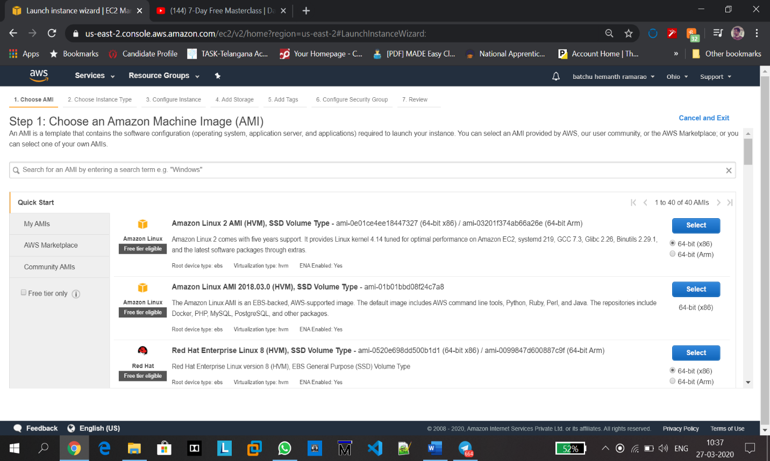

**6. Choosing an instance type:** select t2.micro

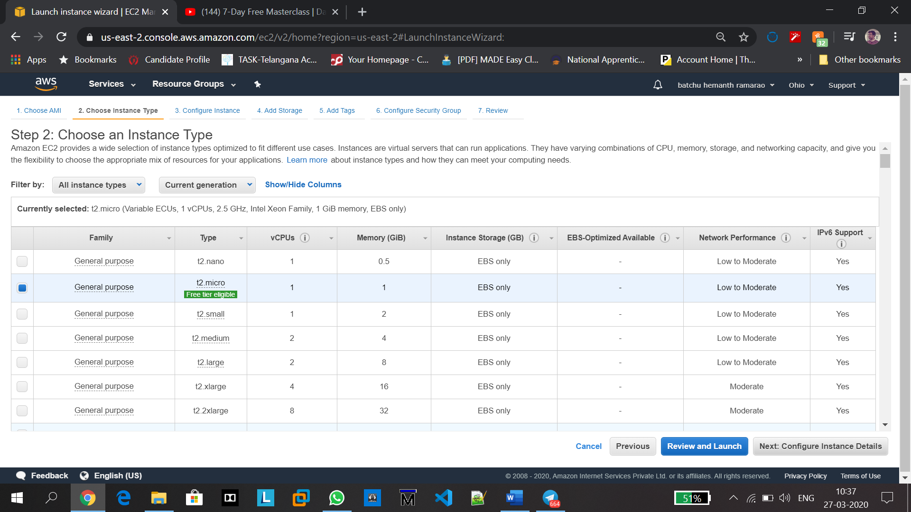

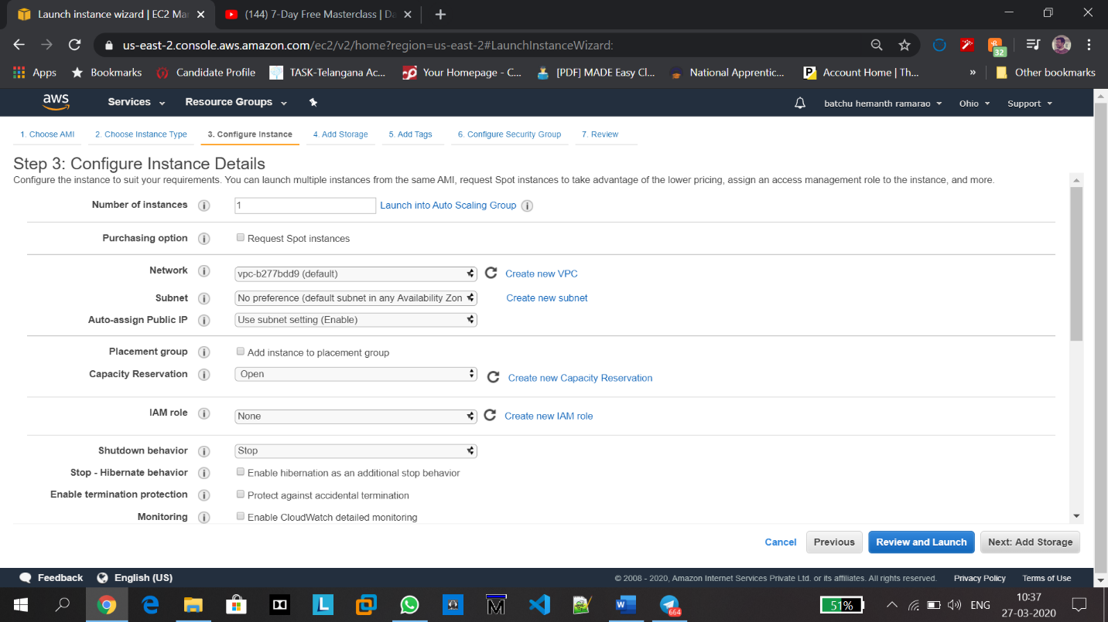

**7. Adding Storage:** Selecting Size(GIB) as 8.

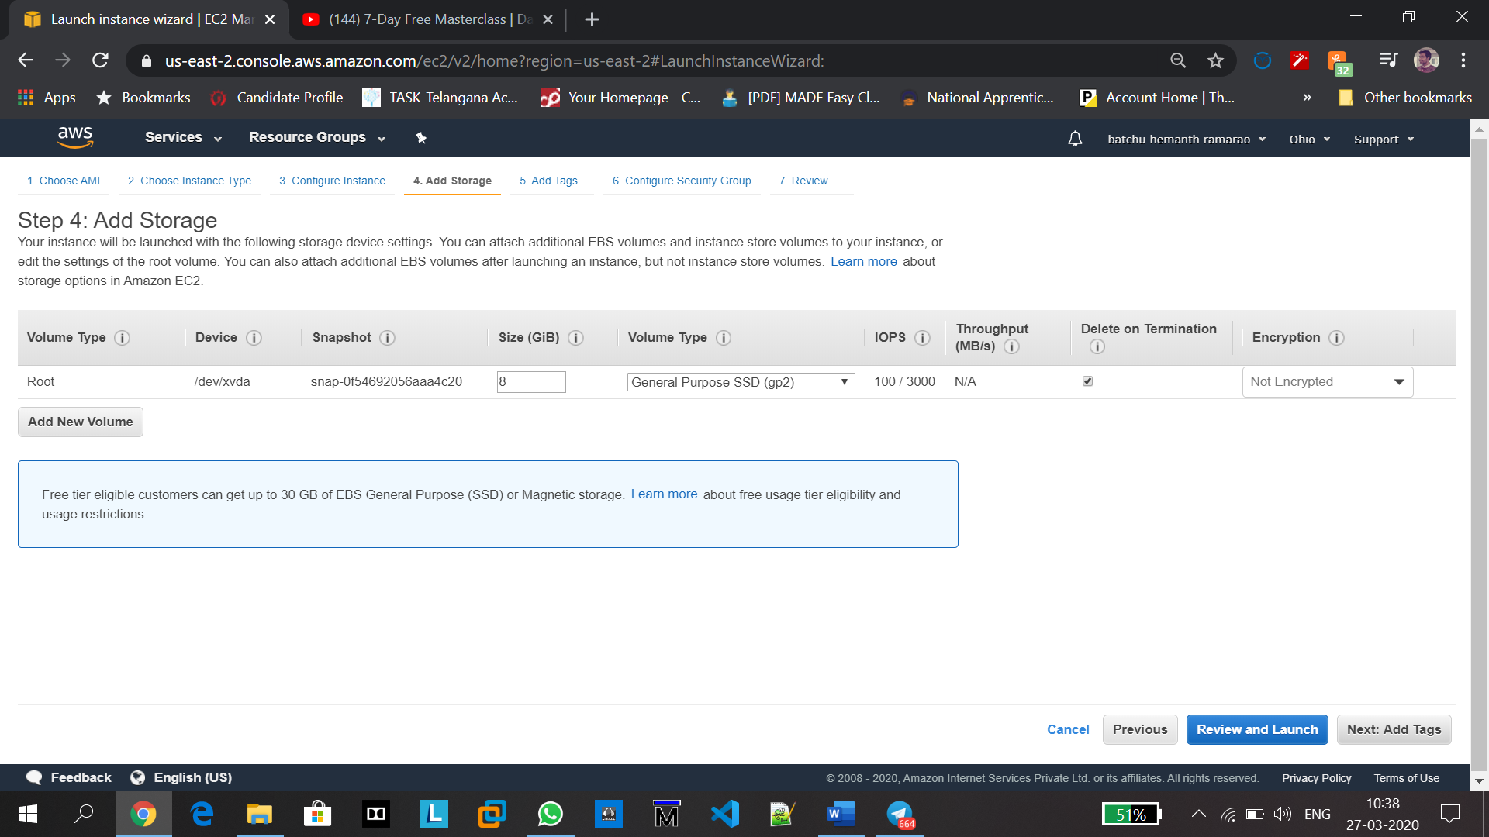

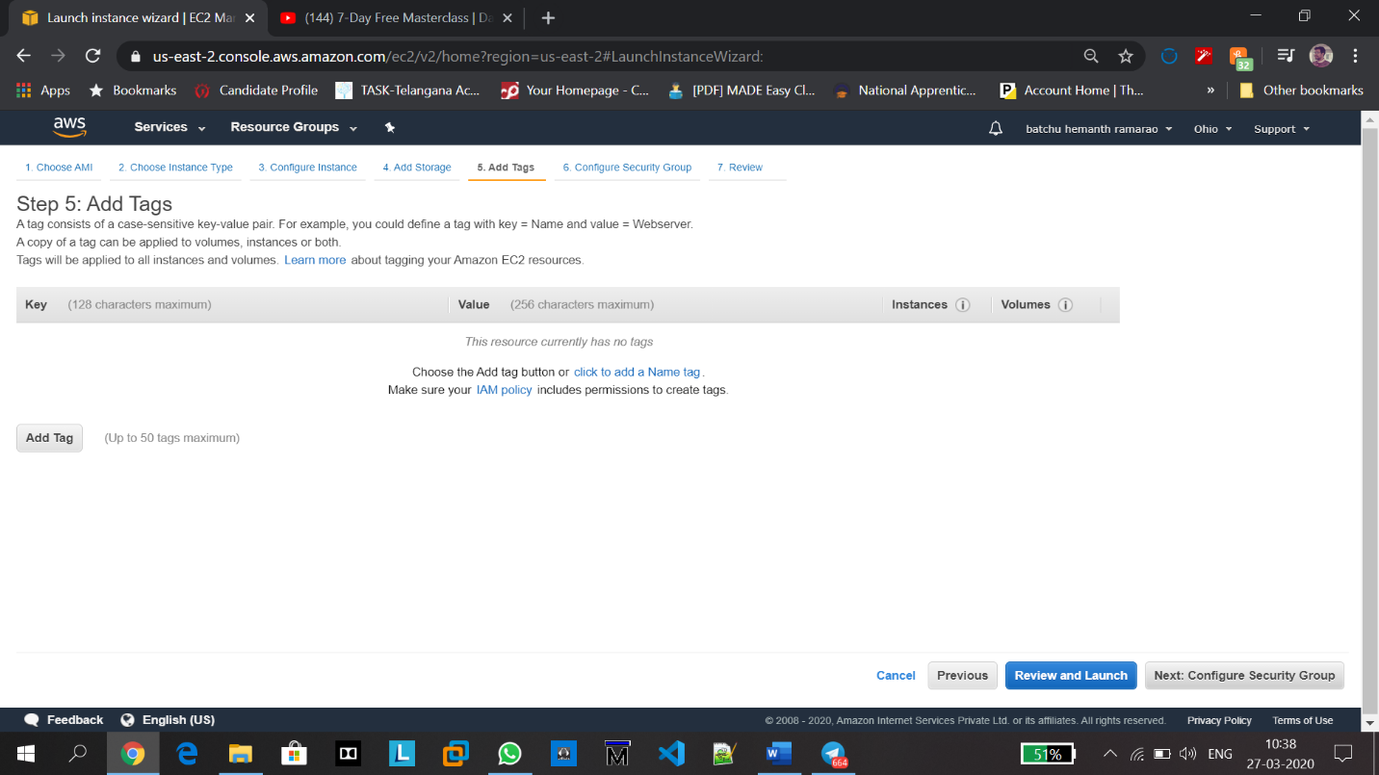

**8. Configuring Security Group:**

Select Type as SSH and Port Range 22

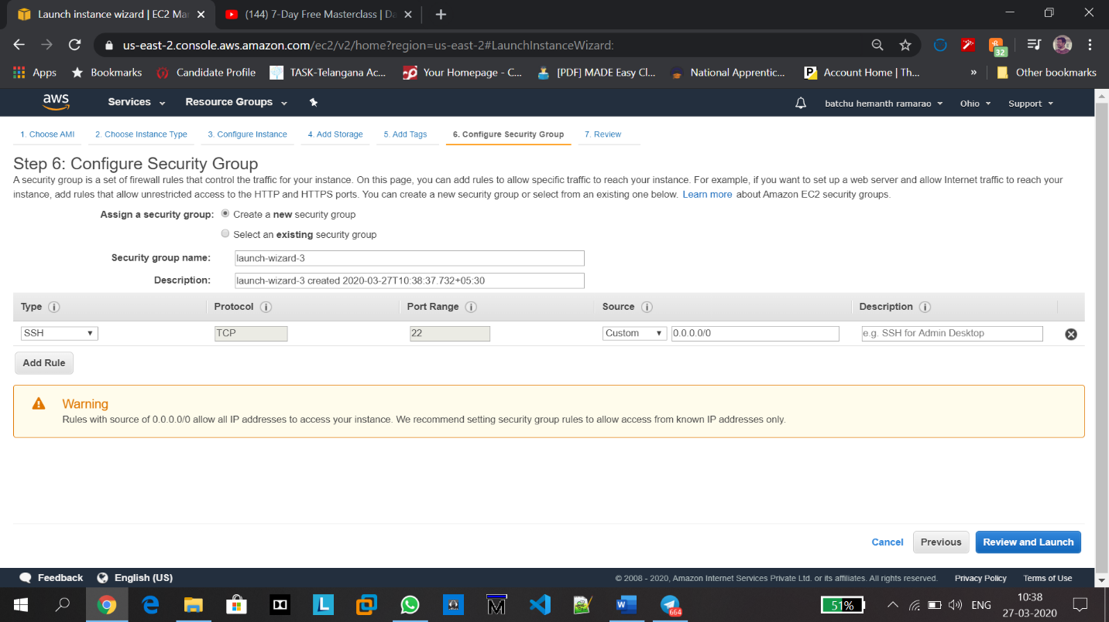

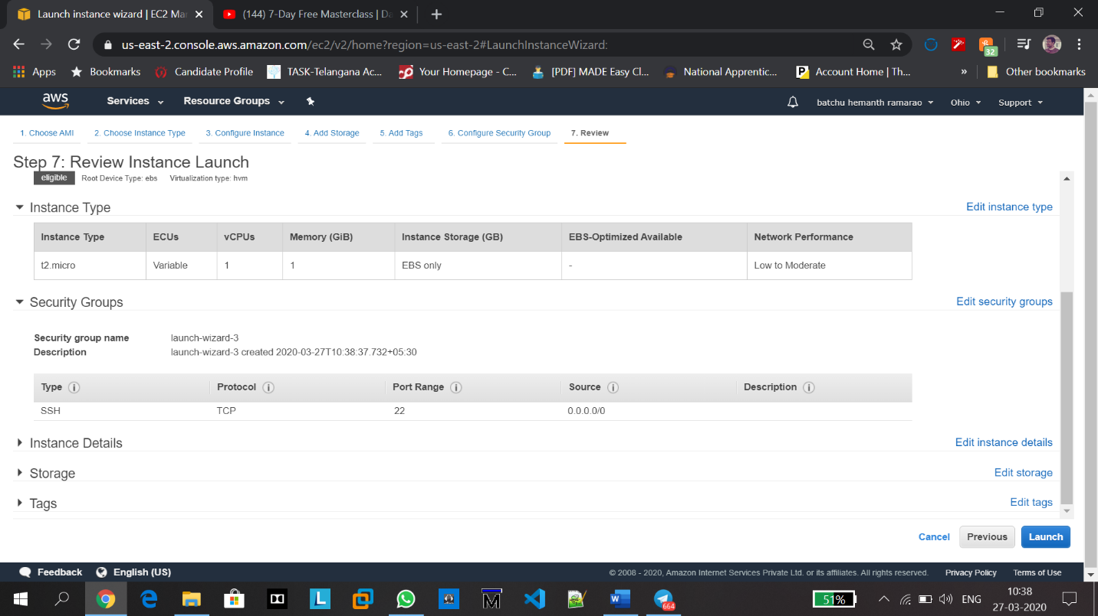

**9. Key Pair Download:**

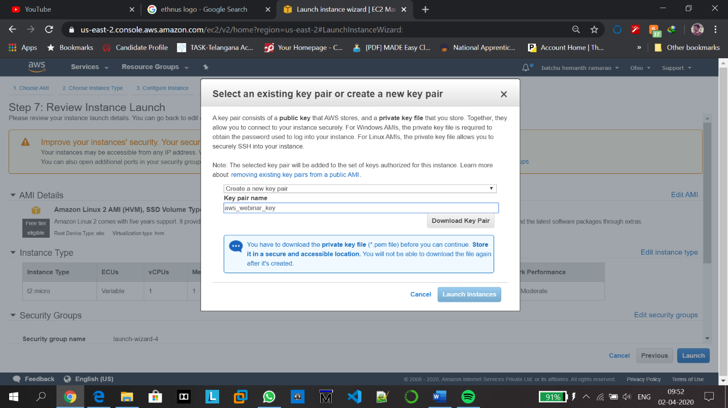

**10. PuTTYgen conversion from pem to ppk:**

In the last line of the following screenshot, you can observe the puttygen command. Before that, putty was installed.

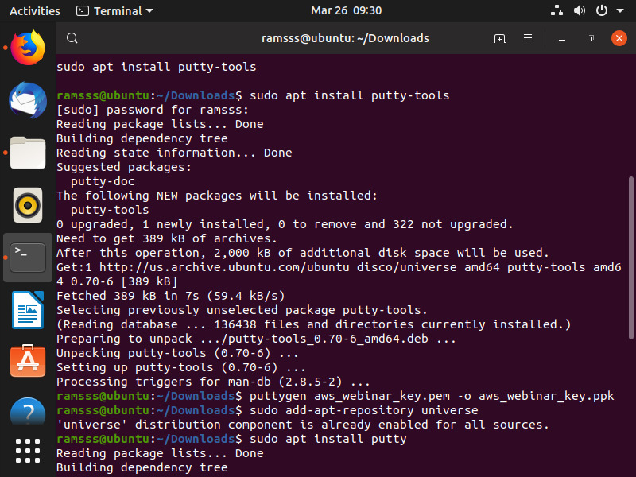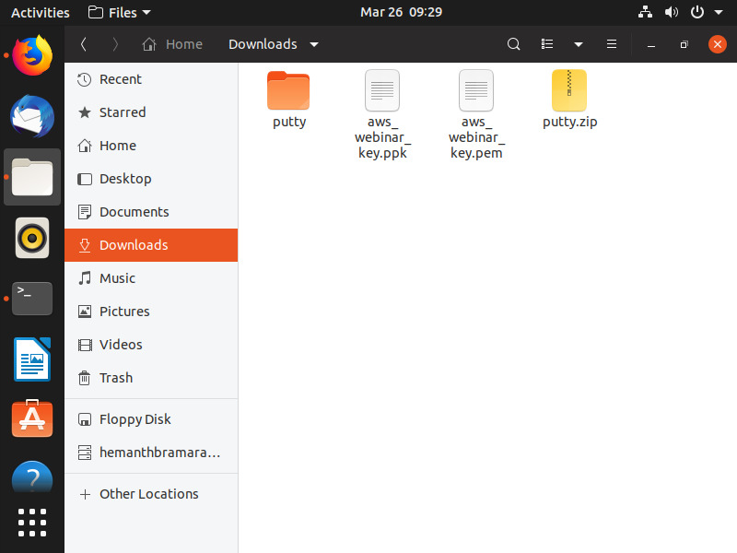

**11. Logged in EC2 Black Screen:**Open putty and paste the IP address of the instance you created using EC2.

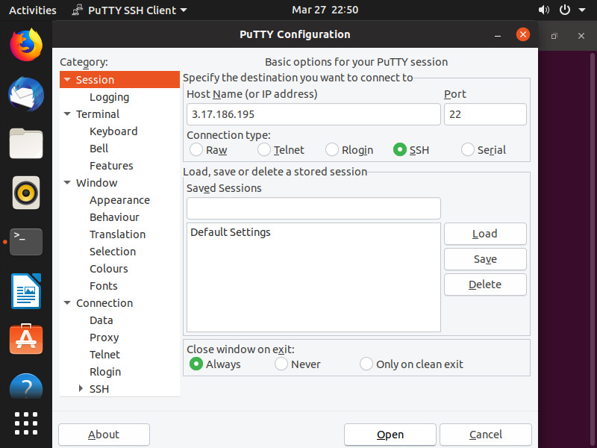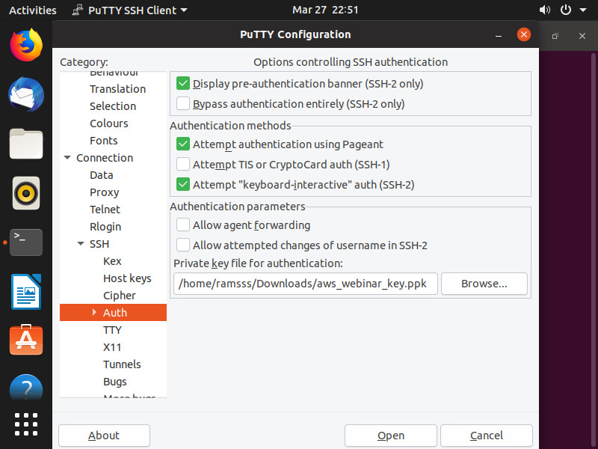

**11. Logged in EC2 Black Screen:**

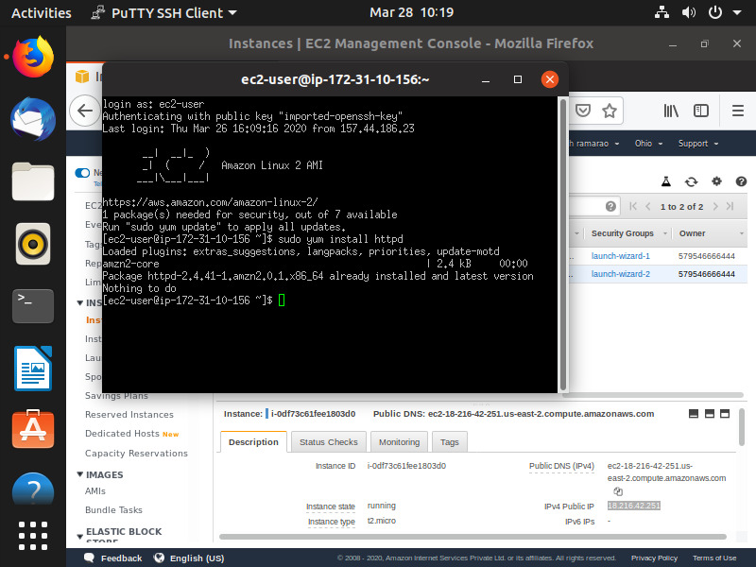

**Day 1 task after logging in to black screen:**

**Installing a server by following commands**

**sudo yum install httpd**

**sudo service httpd start**

**sudo service httpd status**

**sudo vim/var/www/html/index.html**

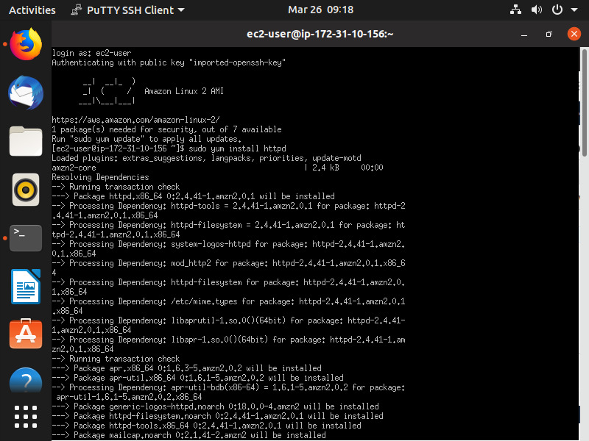

**Checking status:**

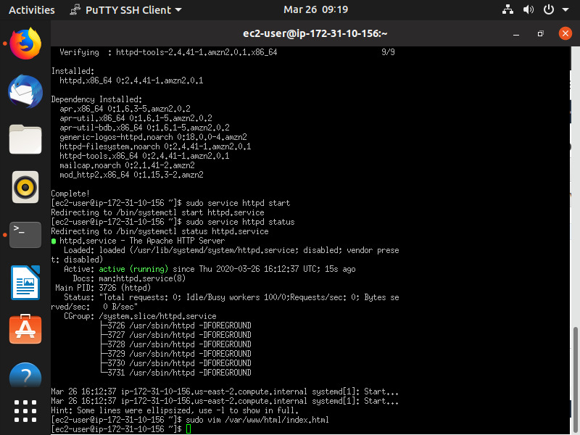

During editing of index.html I wrote

“Hello…I am Hemanth Ramarao Batchu and I am enjoying these quarantine holidays”

**Editing inbound rules to enable HTTP access:**

**Initially:** 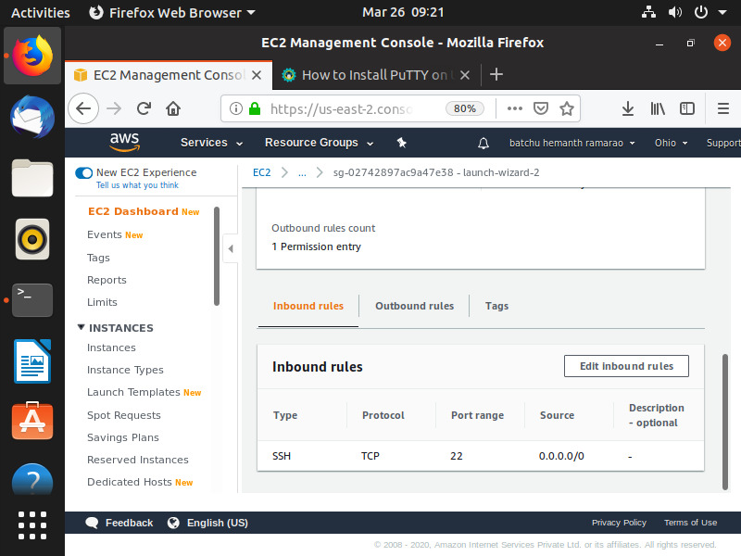

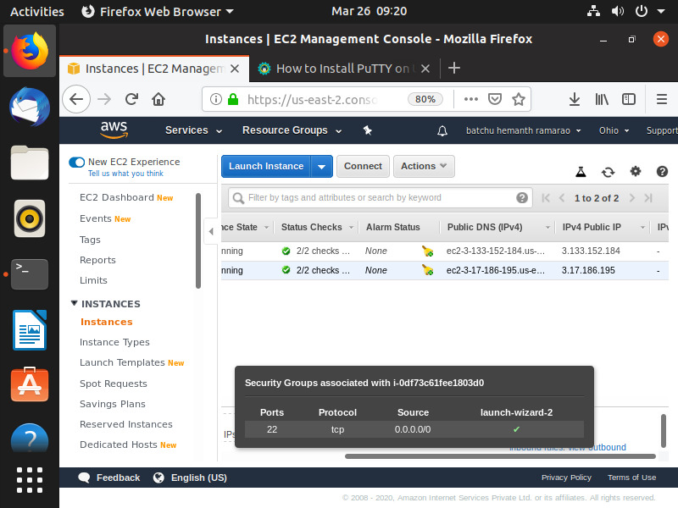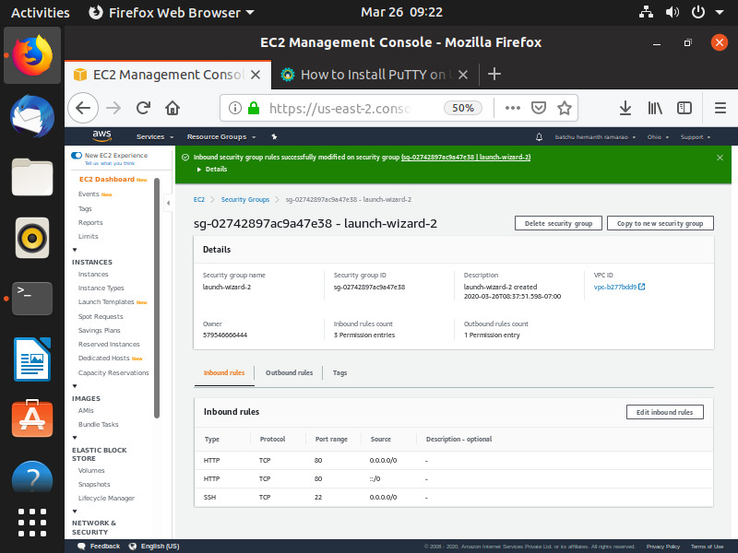

**Finally:** 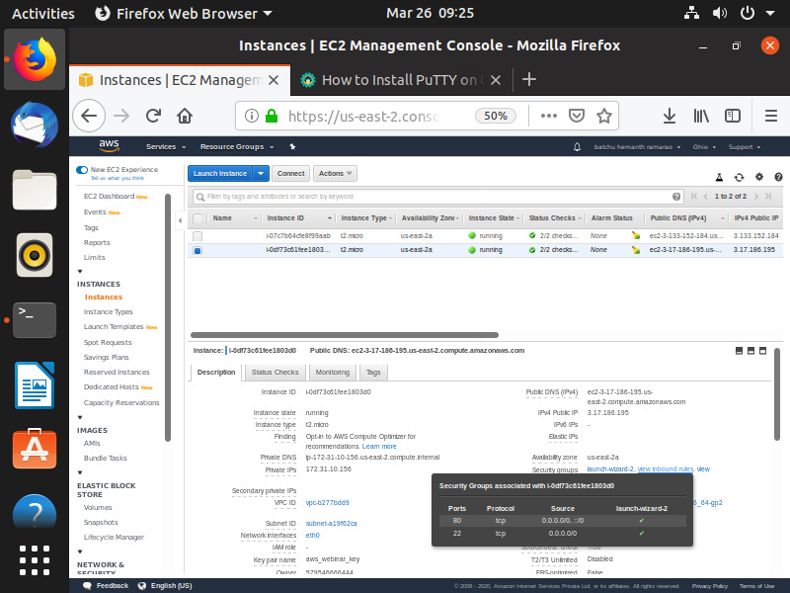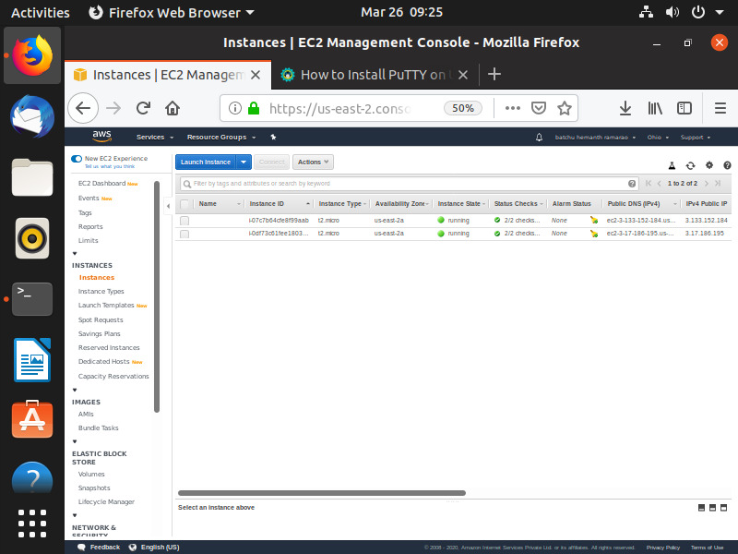

Checking the Final page: 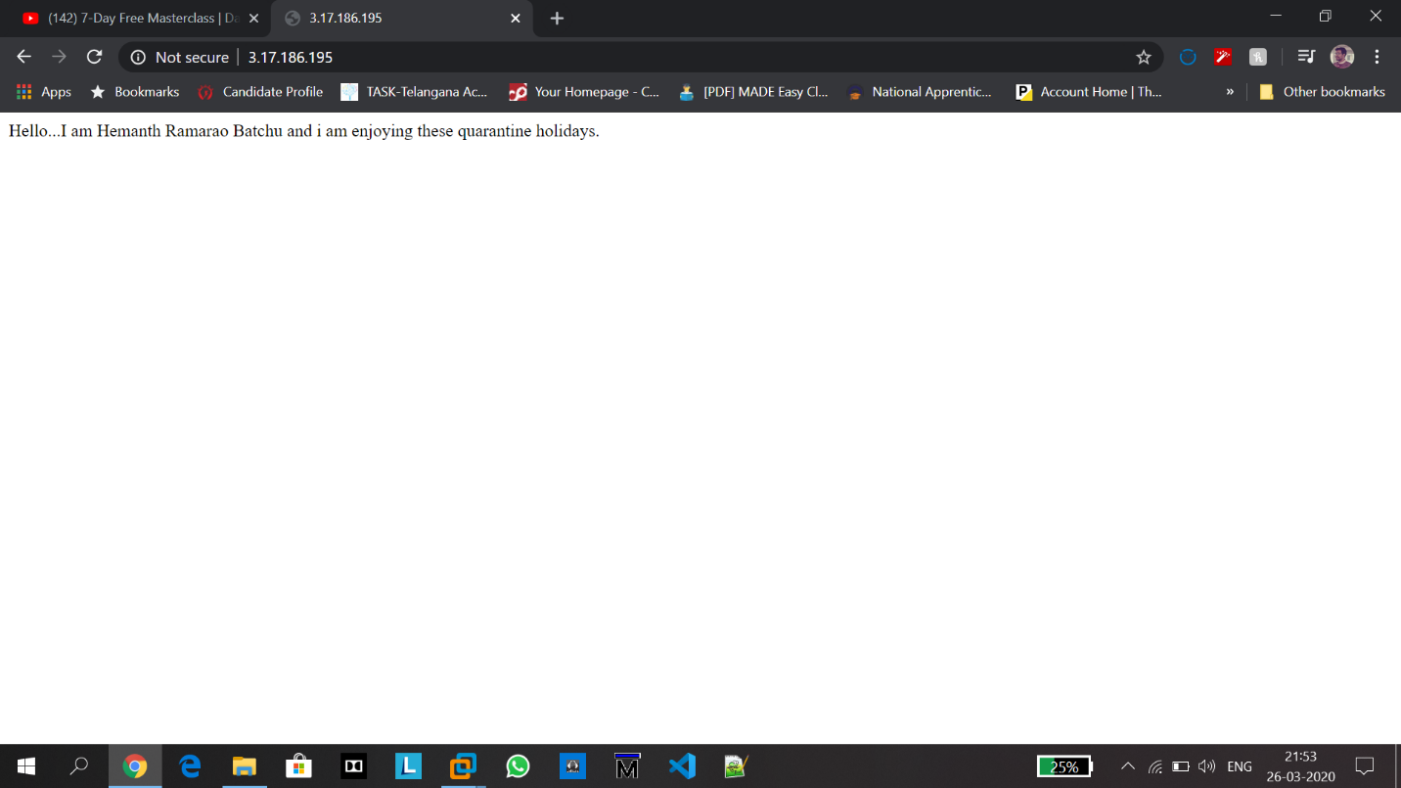

DAY 1 TASK (CREATION OF OWN SERVER) COMPLETED SUCCESSFULLY

**Part 3: S3**

**12.Creating a bucket:**

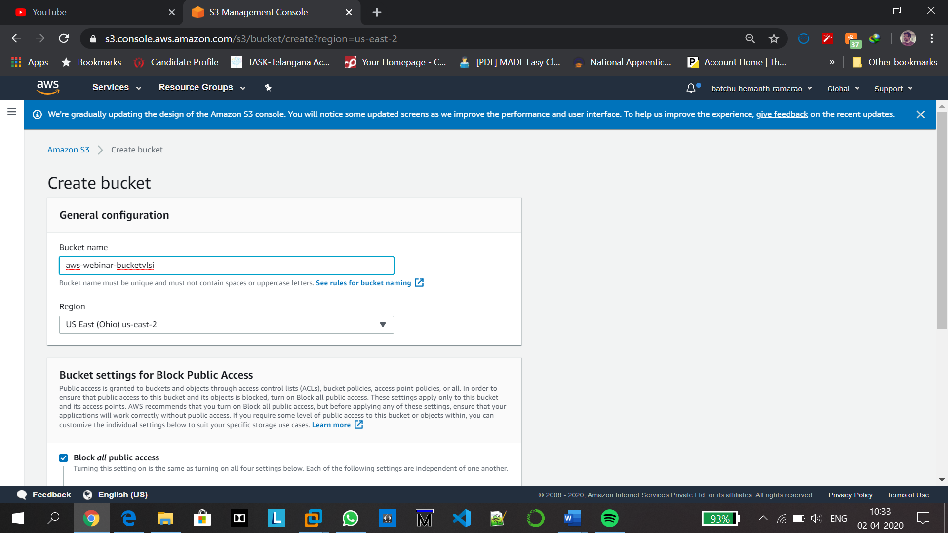

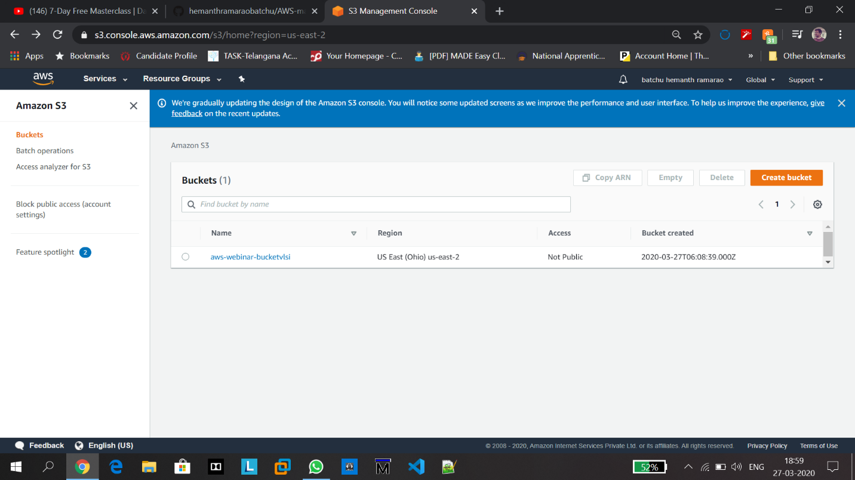

**13.Uploading an Object:**

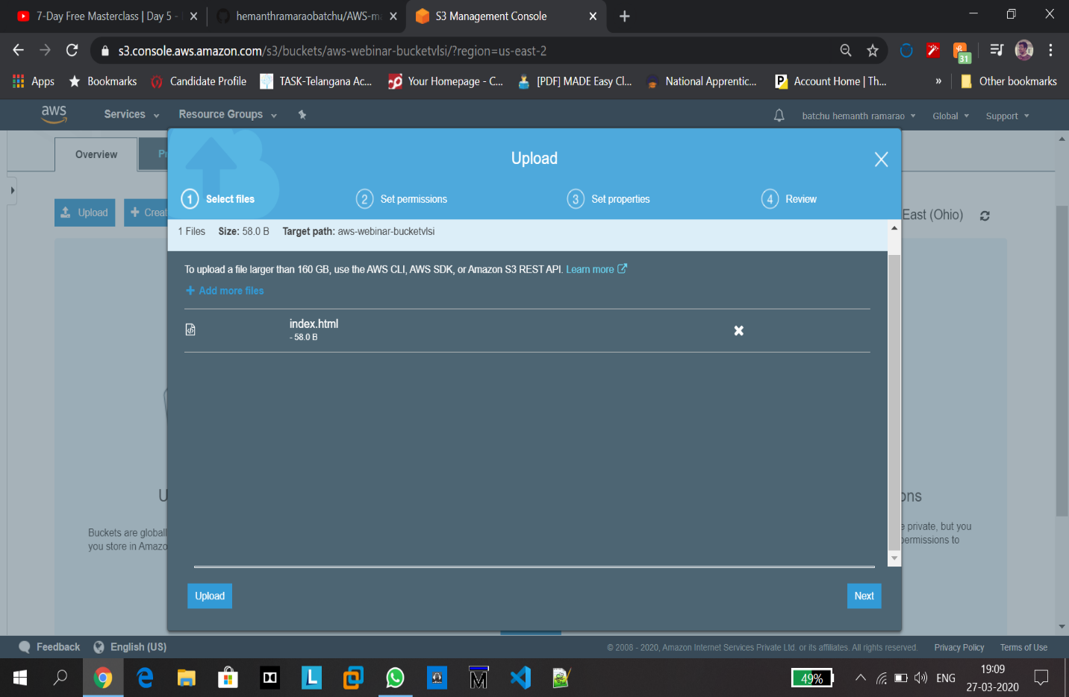

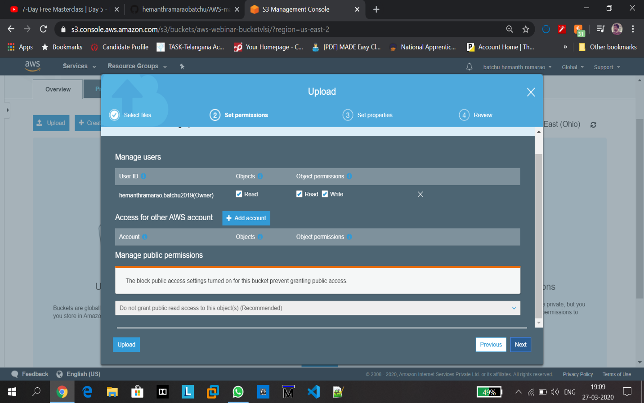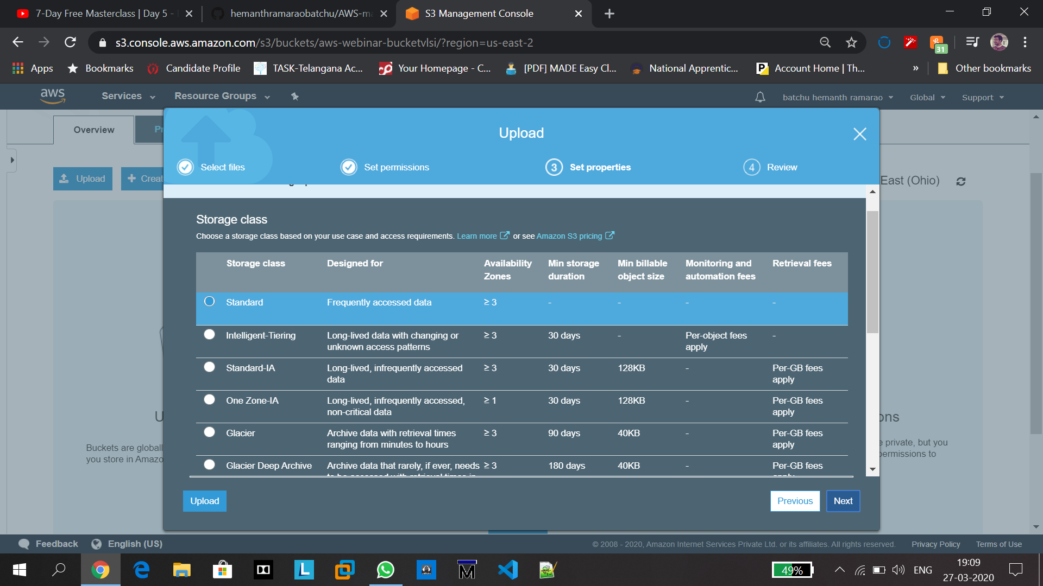

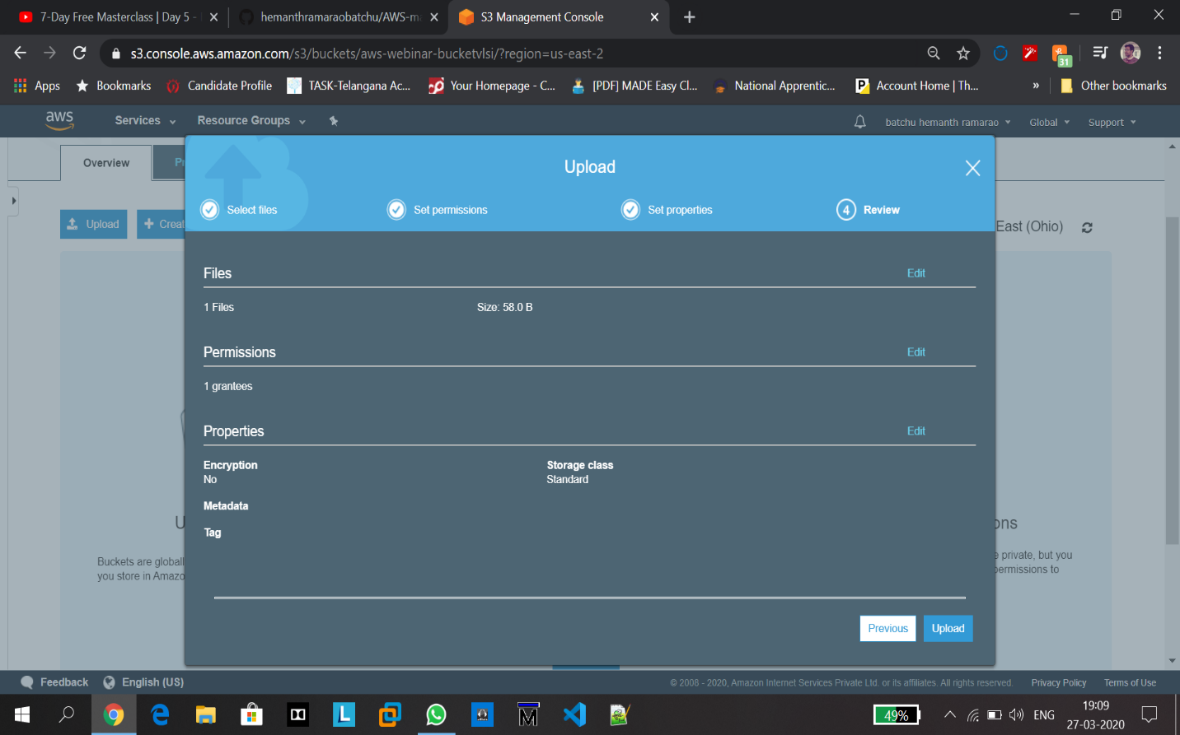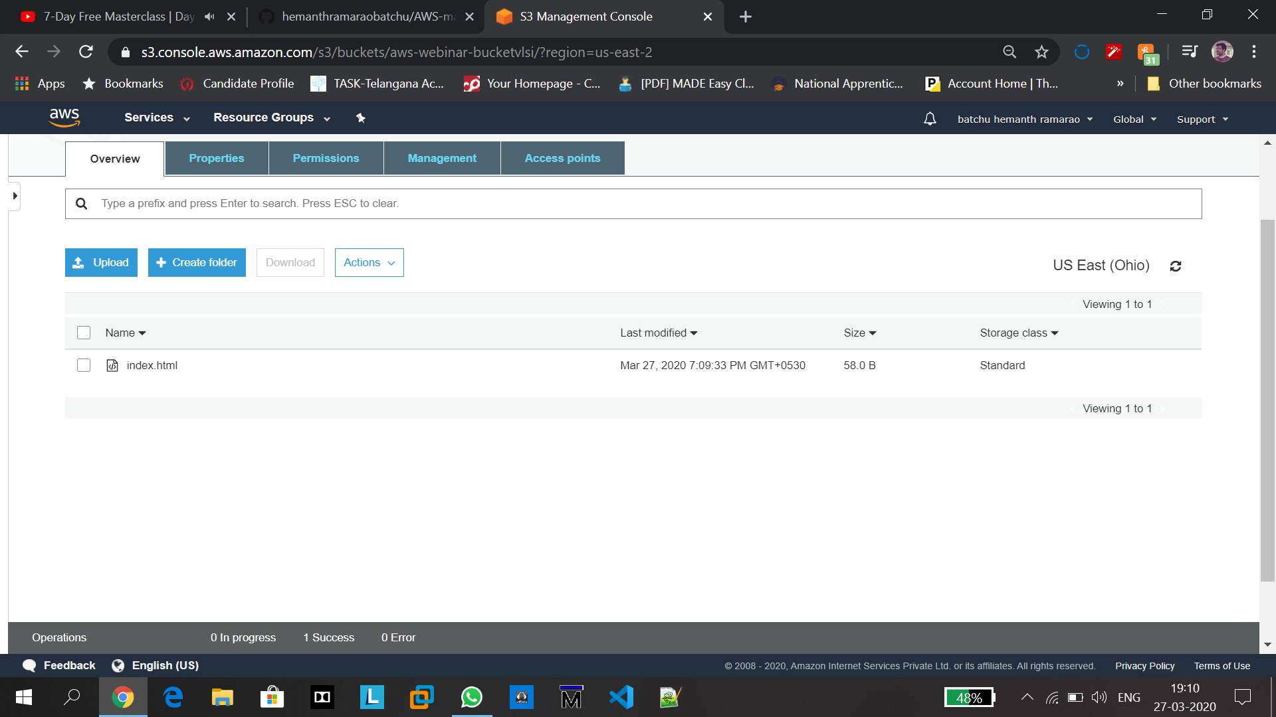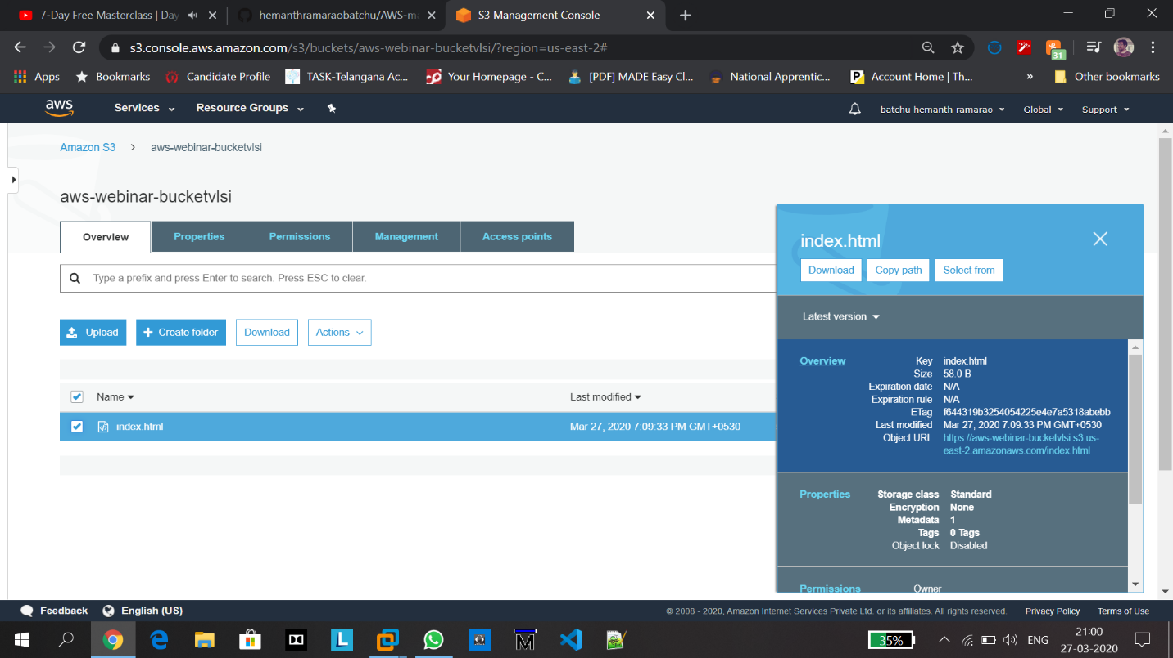

**14.Enabling the static website:**

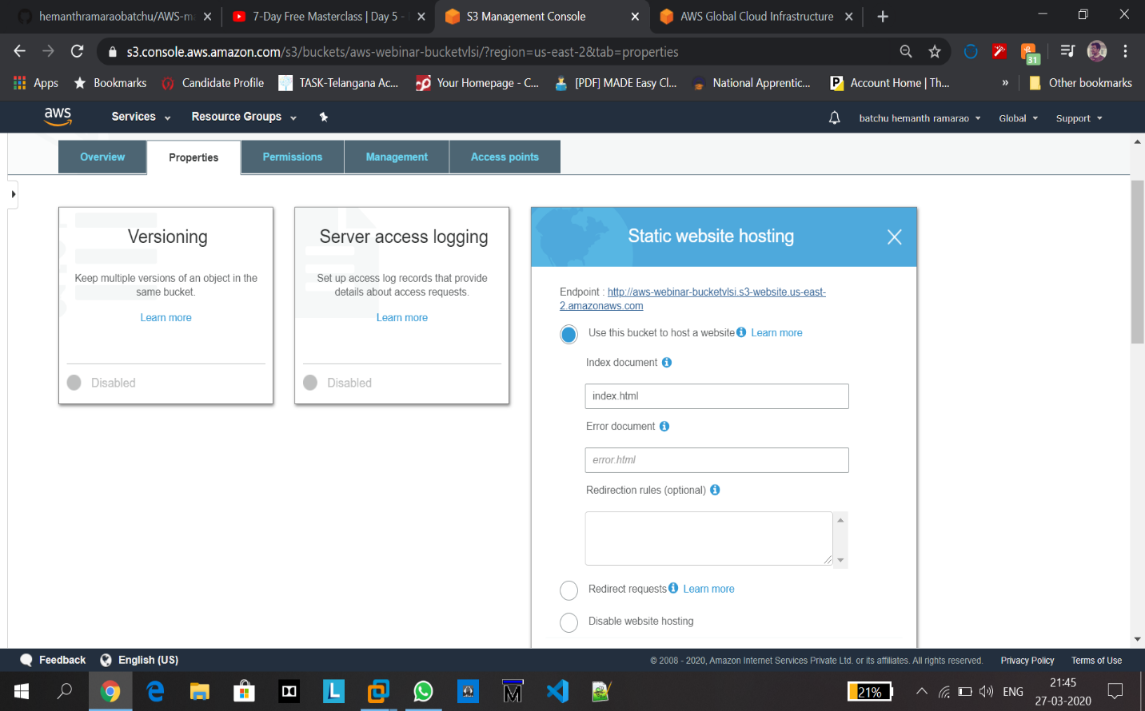

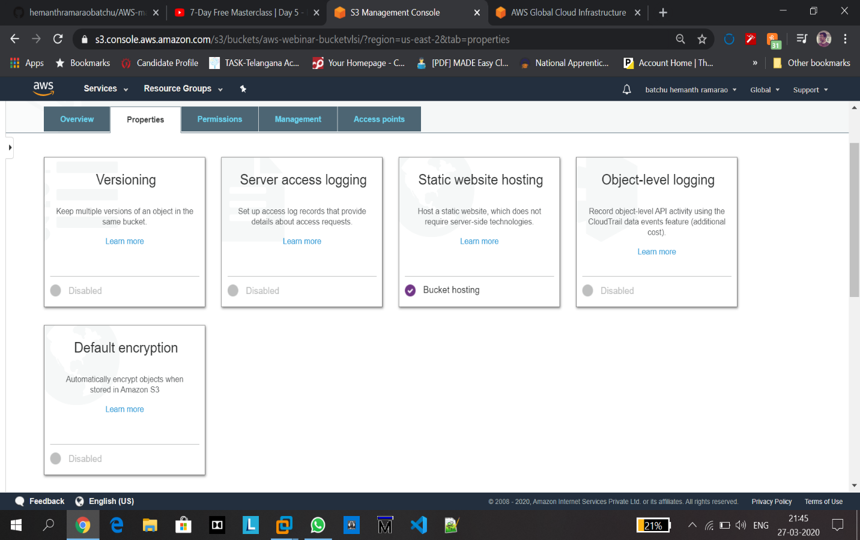

**Still link can’t be accessed.**

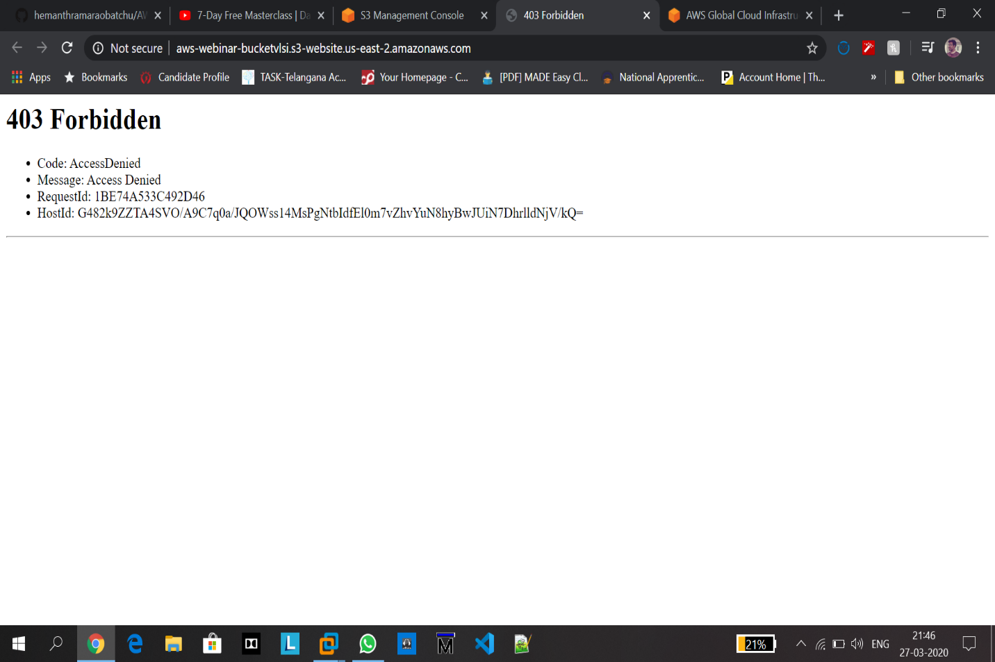

**15. Making the Object Public:**

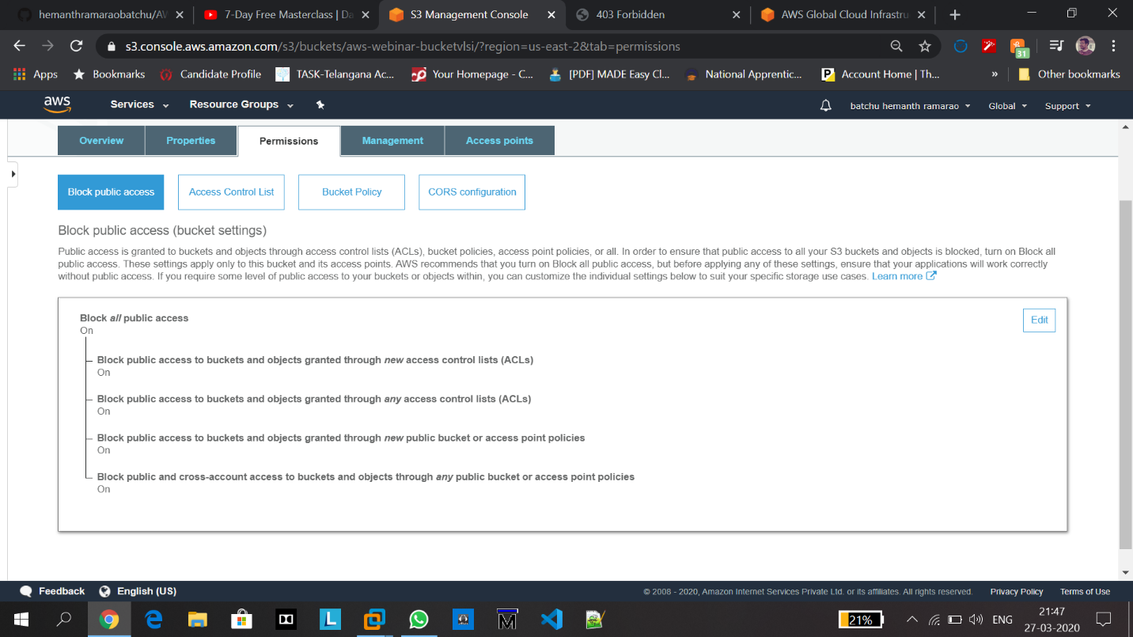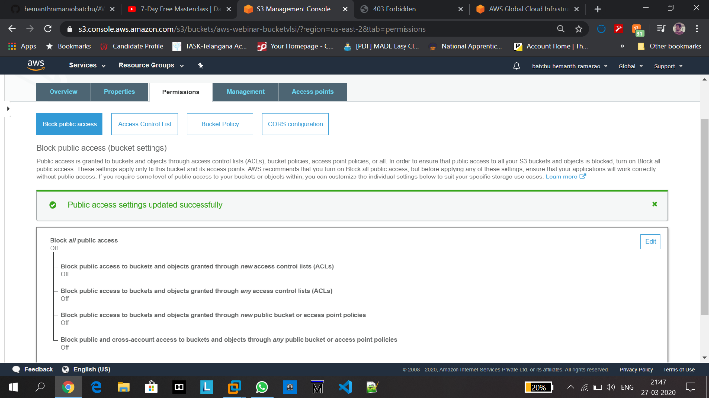

**Here, click “make public”.**

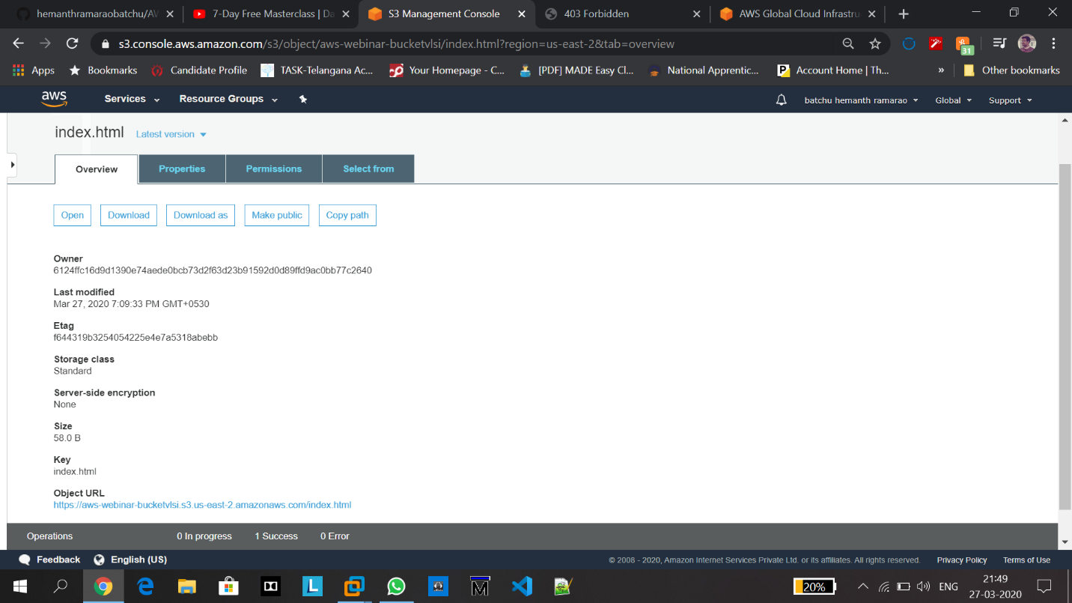

**16. Checking the S3 link on browser:**

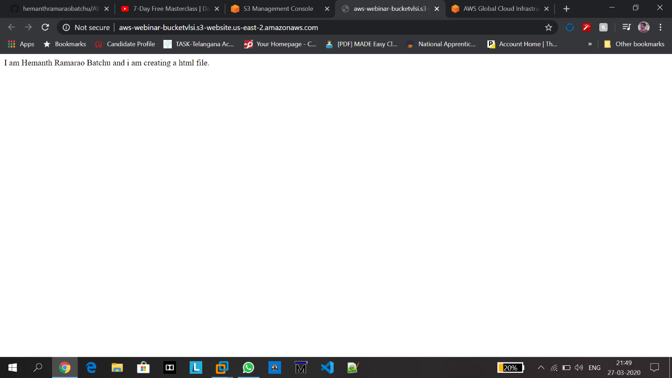

Hosting a Static website is completed successfully which is day2 task**.**

**Part 4: Rekognition**

**17. Face Detect:**

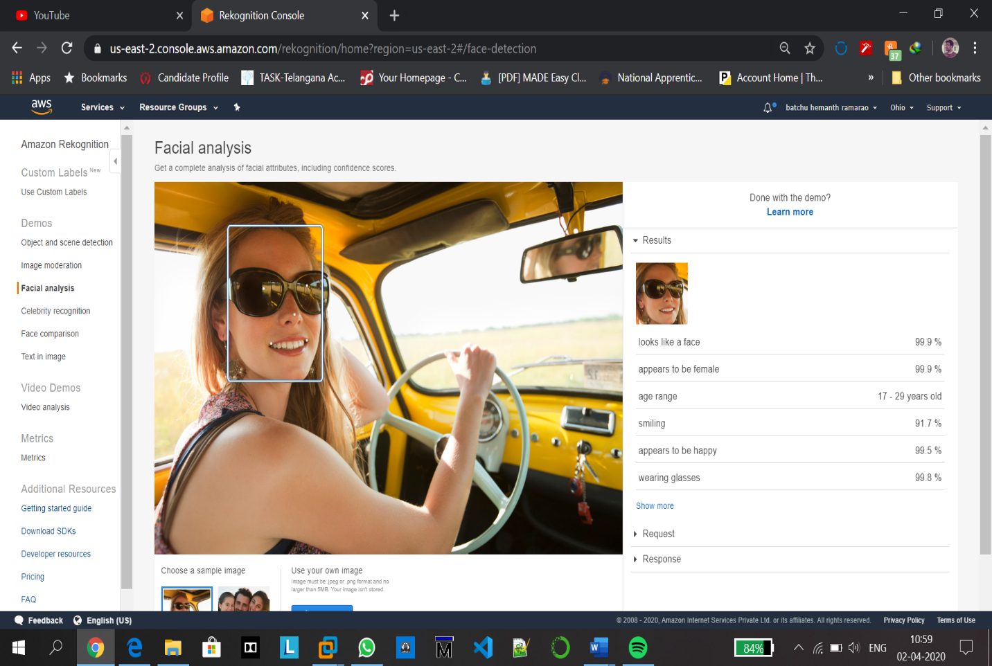

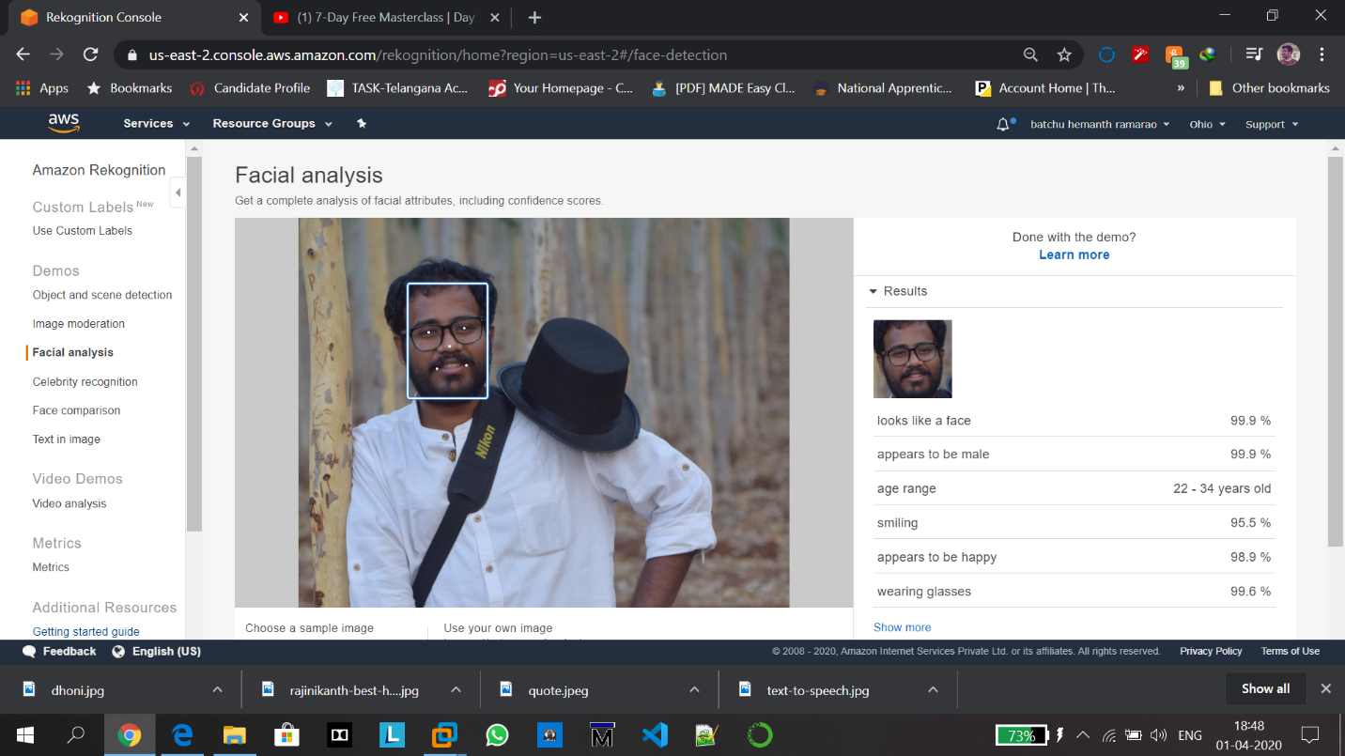

**18. Face Compare:**

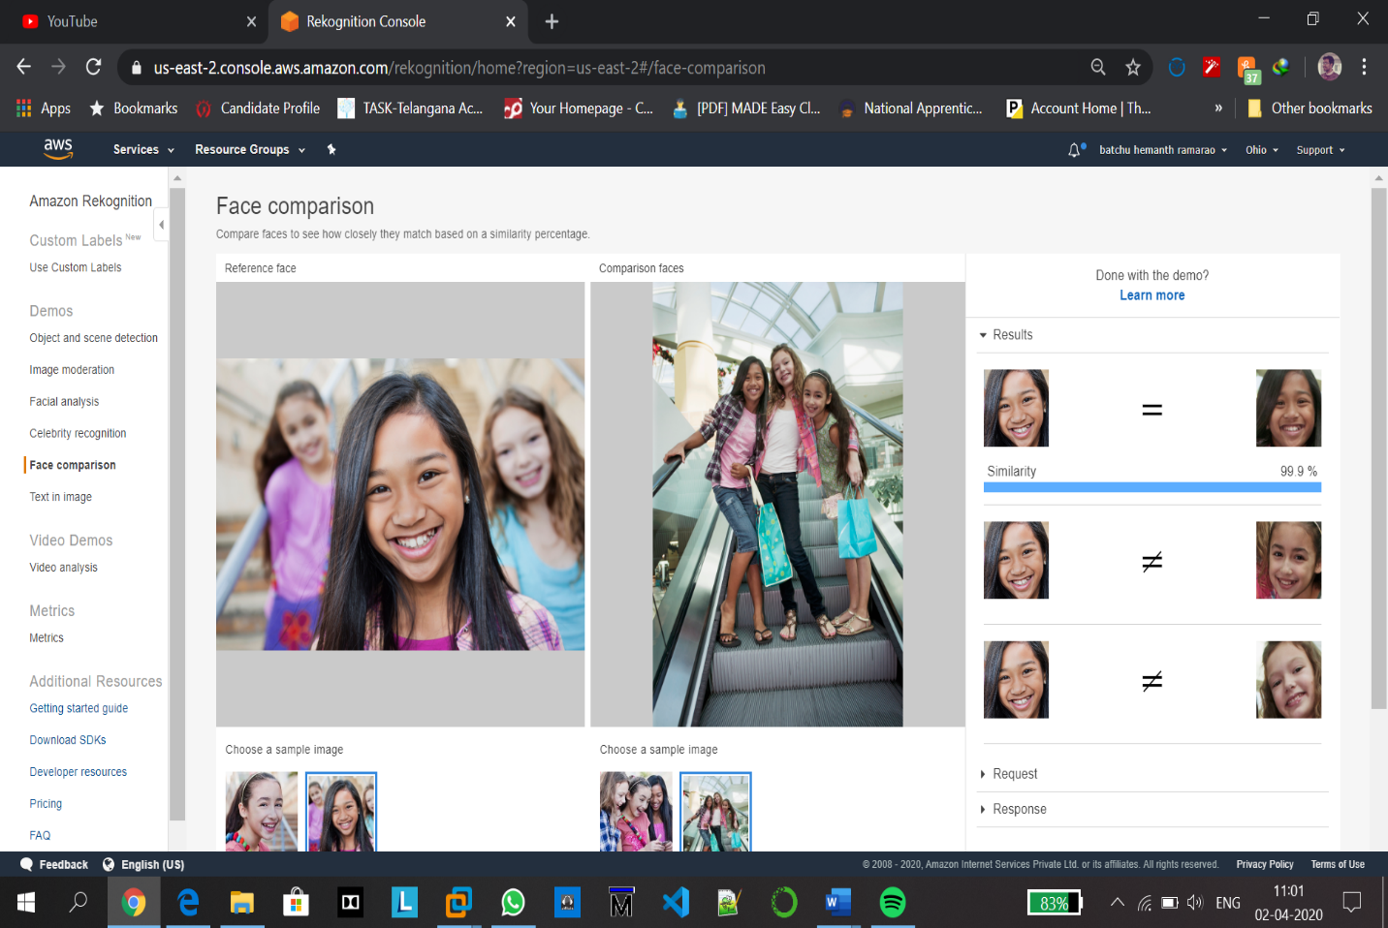

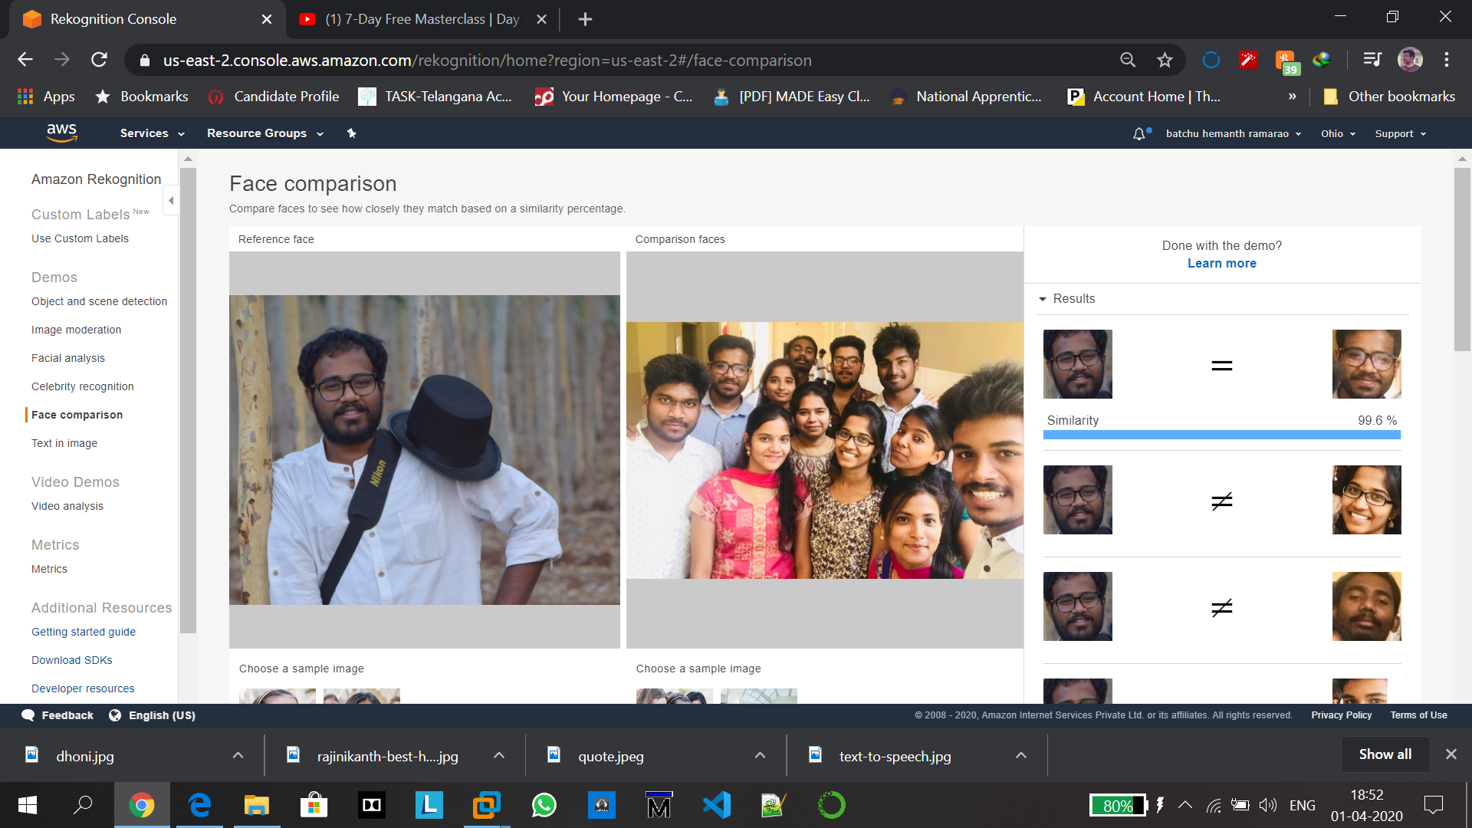

**19. Celebrity Recognition:**

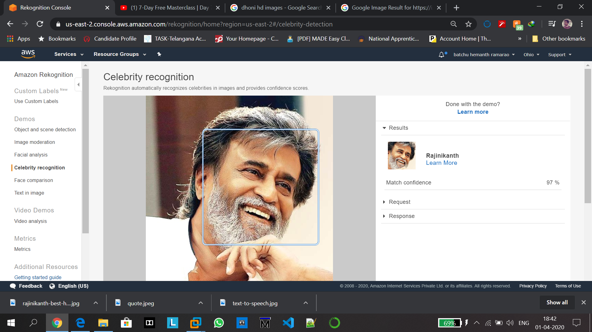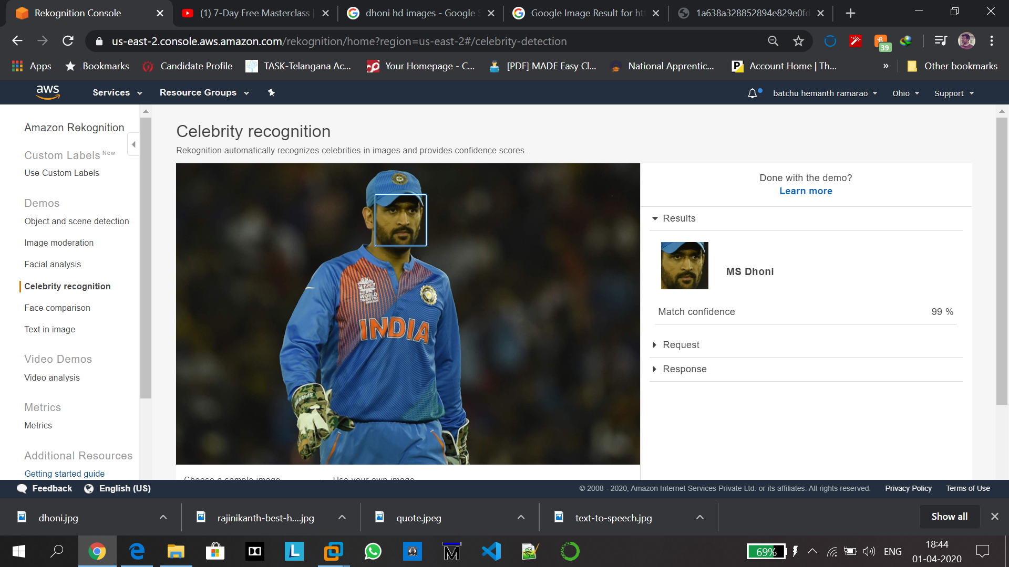

**20.Text in image:**

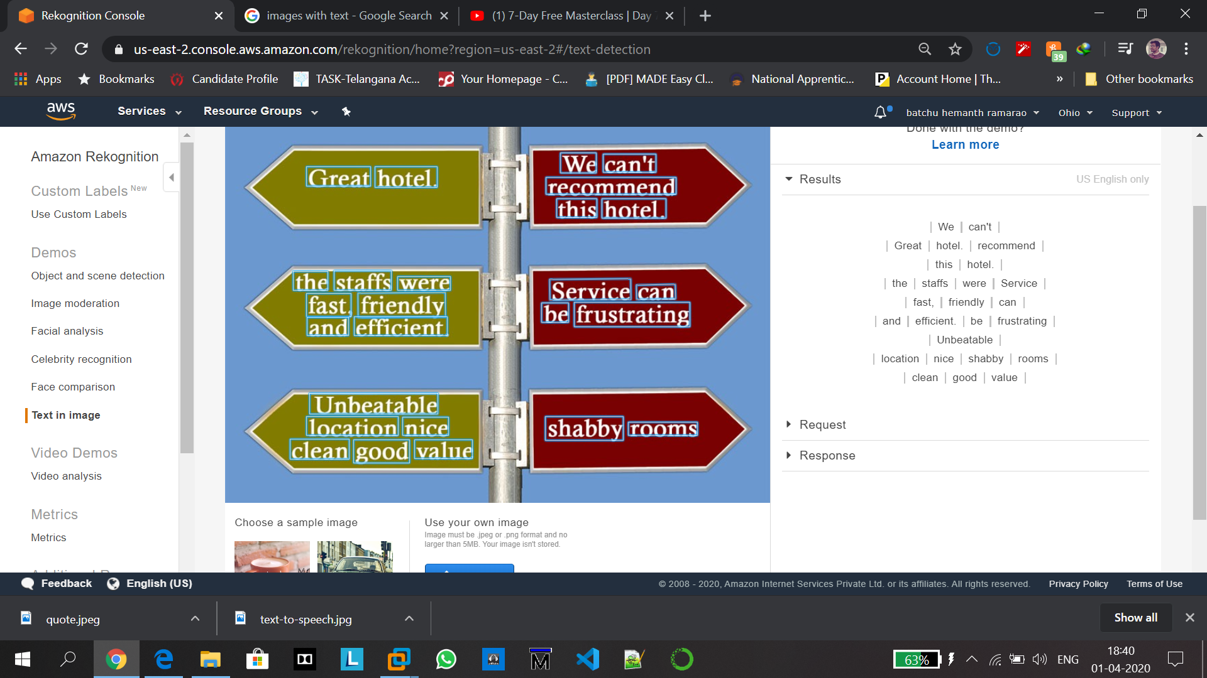

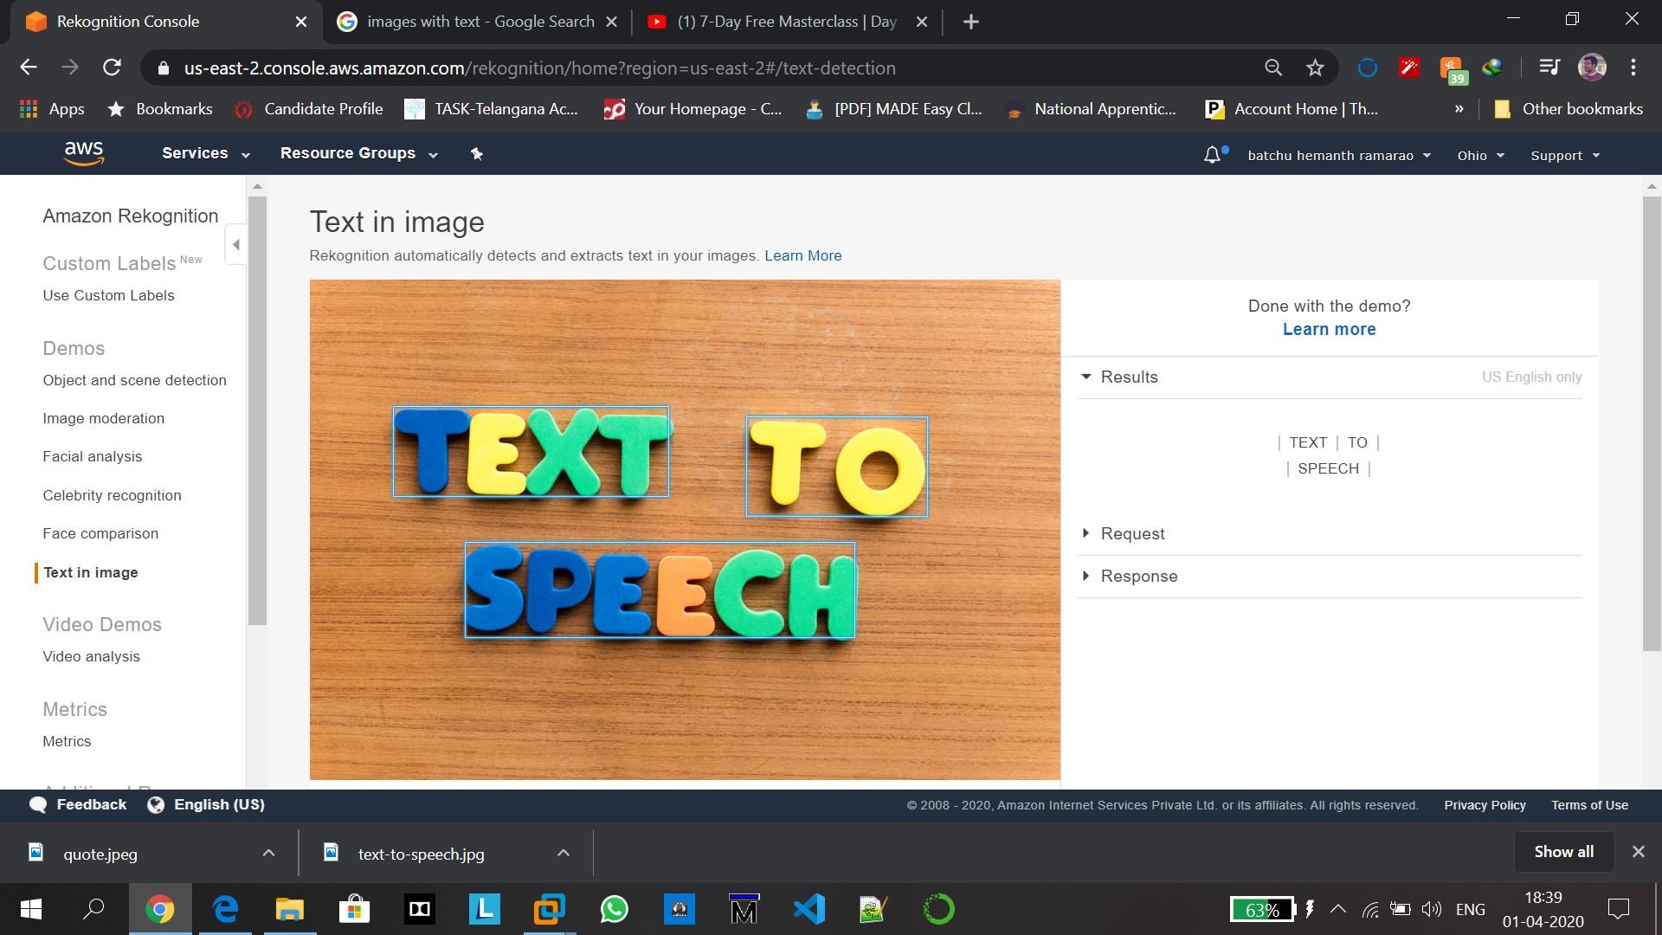

**Part 5: EC2 and S3**

**21,22 Installing php and aws-sdk:**

**PHP installation:**

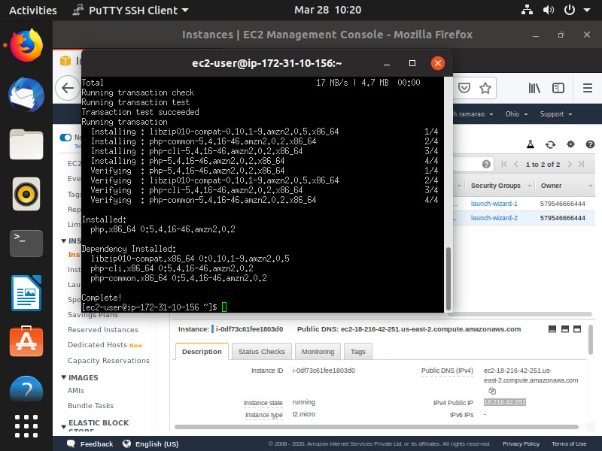

Since I have already installed php and if I run the command again, it will show as “nothing to do” as following:

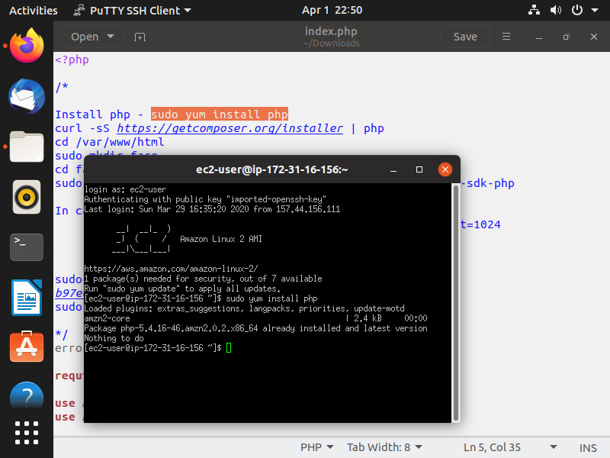

**Composures download:**

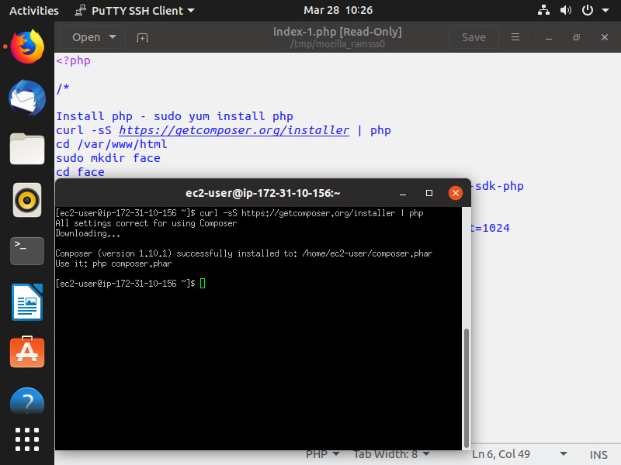

**Aws-sdk installation:**

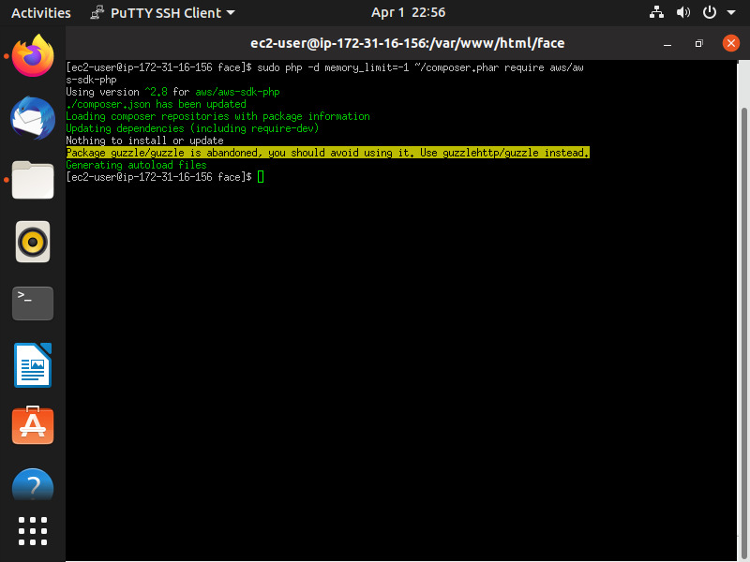

**23. Index.php file Code:**

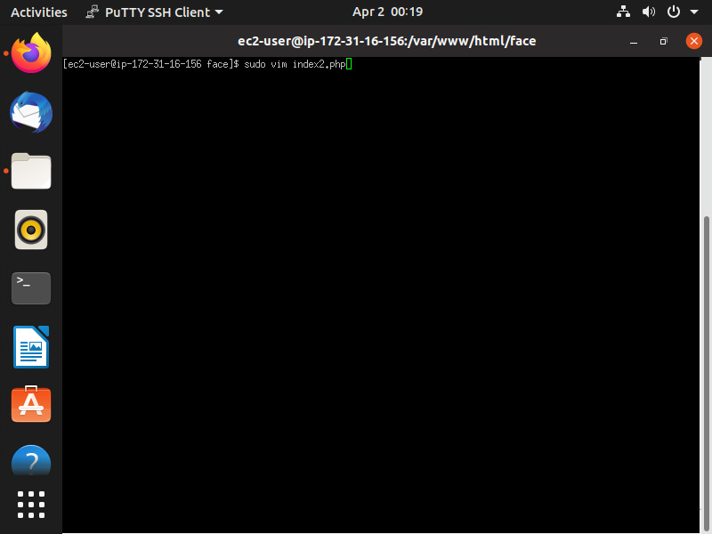

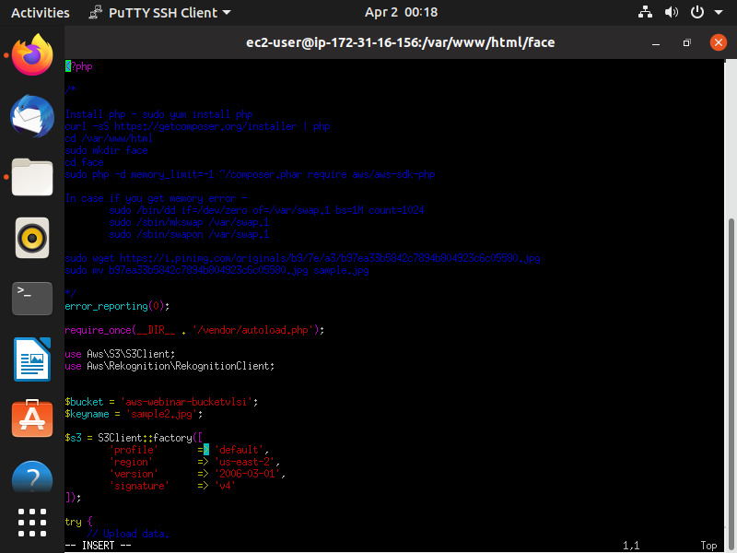

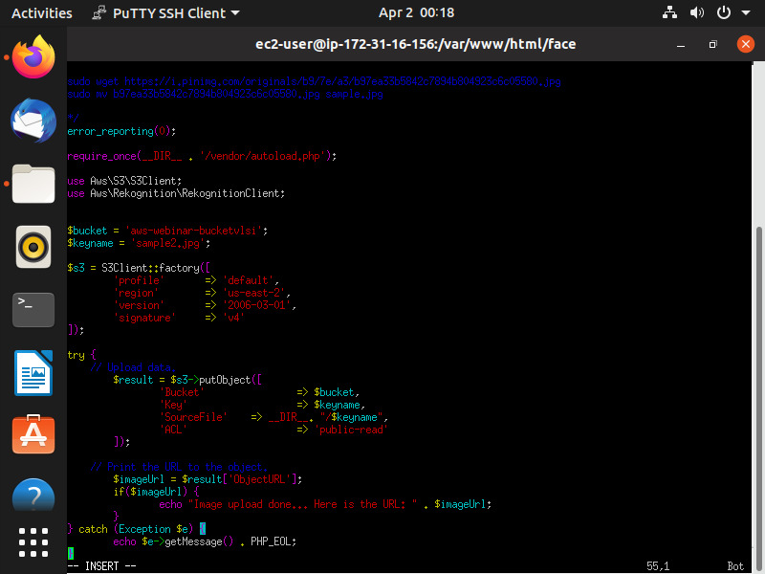

<?php

*/ error_reporting(0);

require_once(__DIR__ . '/vendor/autoload.php');

use Aws\S3\S3Client;

use Aws\Rekognition\RekognitionClient;

$bucket = 'aws-webinar-bucketvlsi';

$keyname = 'sample.jpg';

$s3 = S3Client::factory([ 'profile' => 'default', 'region' => 'us-east-2', 'version' => '2006-03-01', 'signature' => 'v4' ]);

try {

// Upload data.

$result = $s3->putObject([ 'Bucket' => $bucket, 'Key' => $keyname, 'SourceFile' => __DIR__. "/$keyname", 'ACL' => 'public-read' ]);

// Print the URL to the object.

$imageUrl = $result['ObjectURL'];

if($imageUrl)

{

echo "Image upload done... Here is the URL: " . $imageUrl; }

}

catch (Exception $e)

{

echo $e->getMessage() . PHP_EOL;

}

Here, we have to create a IAM role and attach it to bucket so that we can give access and then upload the image to bucket using bucket name in code.

**24.Upload Success screenshot:**

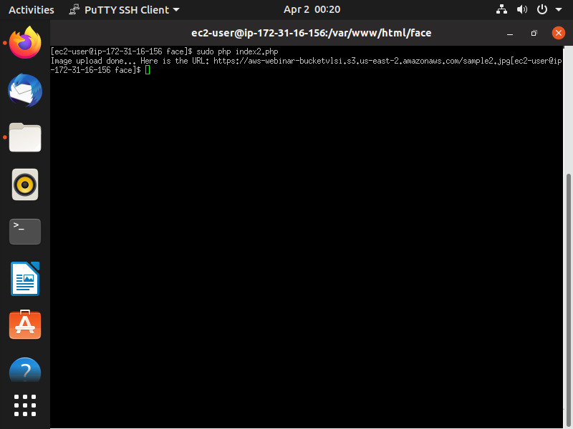

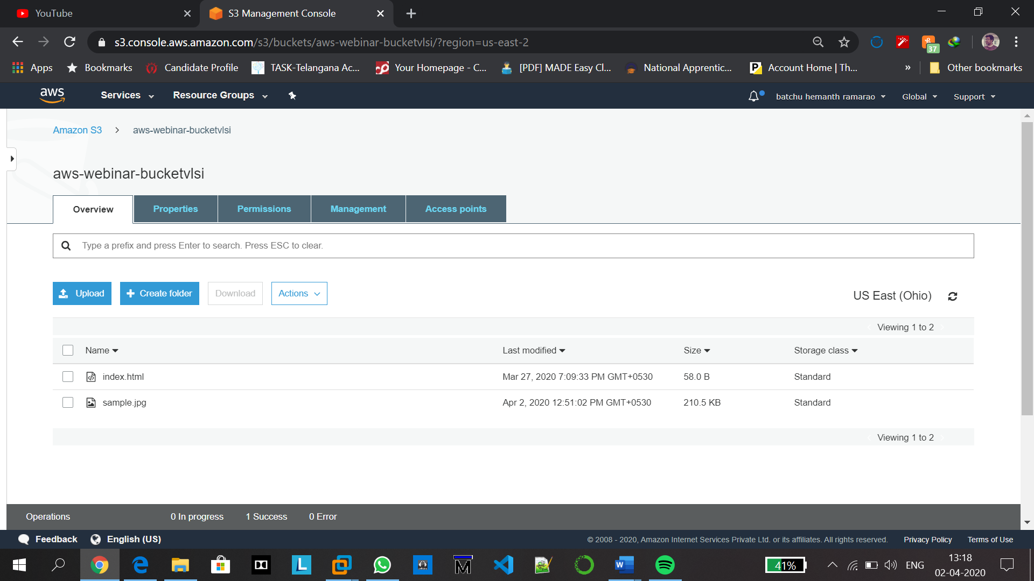

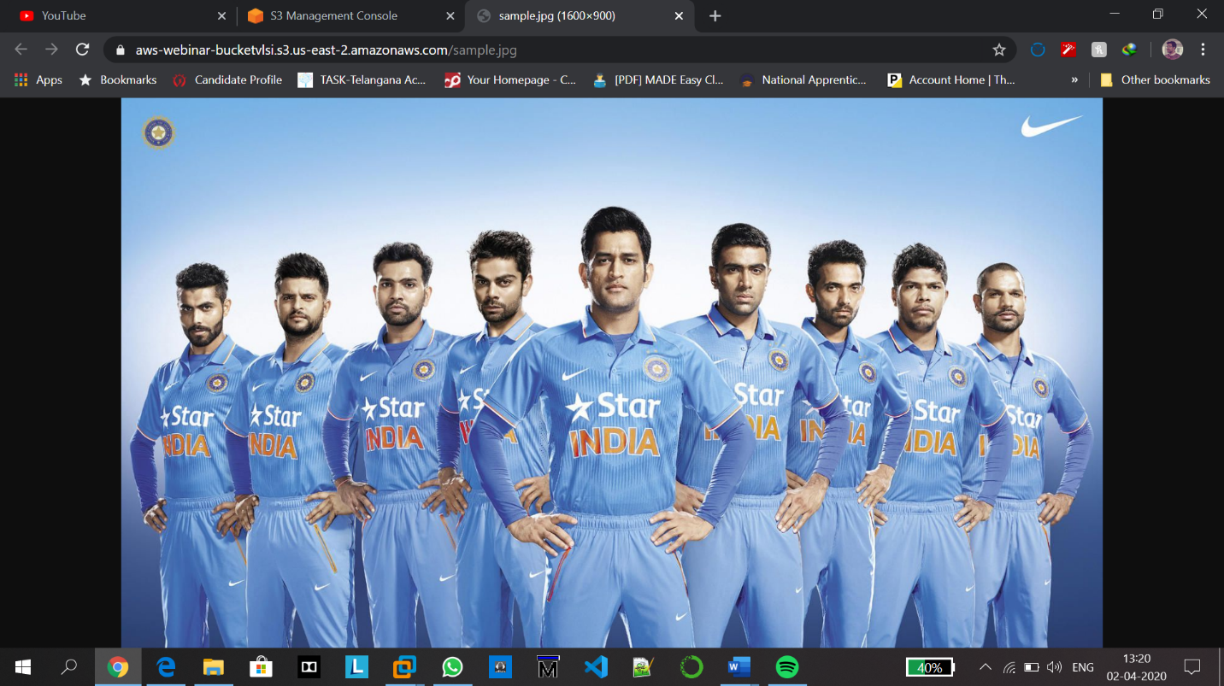

Clearly, we can observe the url and image that got displayed and hence fix that the object upload was successful. Thus an object is uploaded from EC2 and day 3 task is completed successfully

**Part 5: EC2 and Rekognition**

**25. Face Detect success screenshot:**

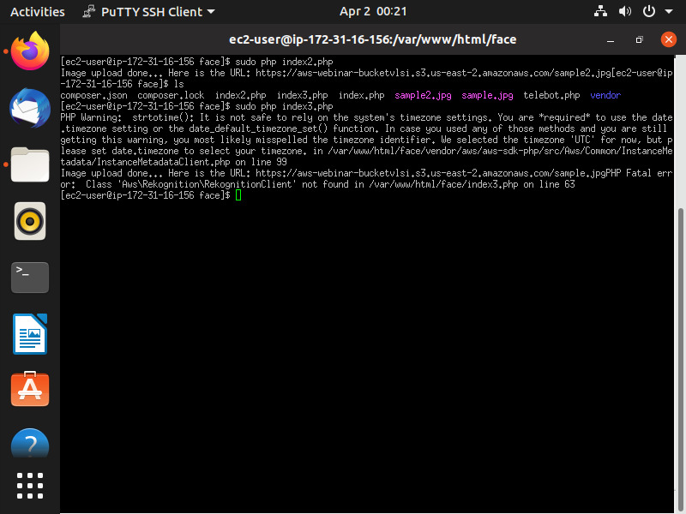

here, image upload is done but recognition of the image was not done due to the error which was not rectified. I reported it in the google form also but there is no response. i hope this is not a issue in certification.

Thus, face detection through aws is done.

Thank you.